Our ref: JPC/MK
Your ref:
18 September 2017

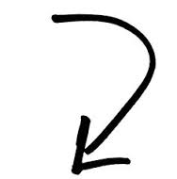

Dear Year 1 & Year 2 Parents

LABELLING OF
UNIFORM ITEMS

Which one belongs to your child? Who knows!

If you can imagine a class-full of uniforms after children get changed for PE you will know why a child goes home with a shirt or jumper or other pieces of uniform that doesn’t belong to them!

If uniform items aren’t labelled your child will not be able to identify which shirt / other part of their uniform belongs to them.

Could we ask you to make sure your child’s name is written inside every item of uniform.
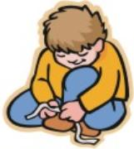
We also find children are having difficulty in fastening buttons and laces and would appreciate parents having some practise sessions, especially before a PE day!

A Reminder…

… that black school shoes are part of our uniform (trainers are not suitable)

