Our ref: JPC /LH / MK
Your ref:

21 September 2017

Theme Day: Health & Wellbeing
Friday 29th September 2017

Dear Parents & Carers

Our PSHE curriculum this term is all about health and wellbeing and we have planned a theme day on Friday 29th September in order for our children to be well-equipped with the skills needed to develop and maintain good health and wellbeing.
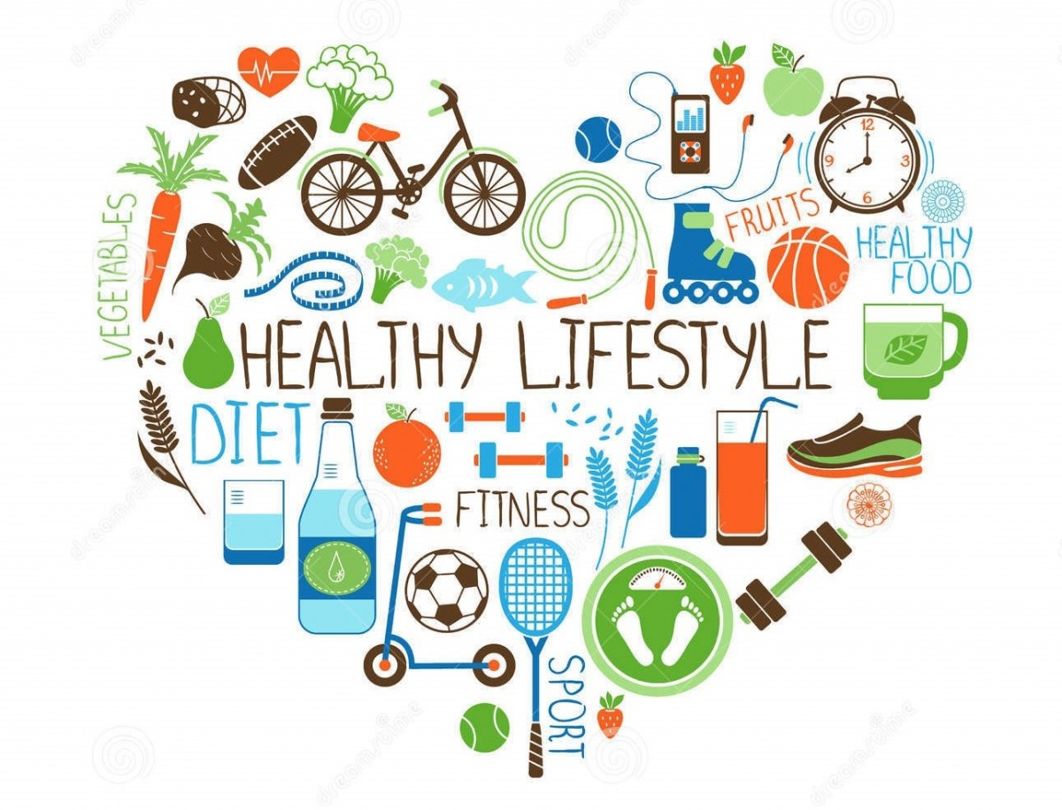

Children to pay £1 to wear their OWN CLOTHES.

Below is the theme for each class:

Year | AM  Physical health and wellbeing | PM  Mental Health
EYFS | People who help us | Recognising feelings: Identifying feeling words
Y1 | Medicines and people who help us | Big feelings and expressions
Y2 | Personal hygiene and health | Recognising feeling words, big feelings and expressions. Hearing drawing and being
Y3 | Smoking | Recognising Feelings words: Facial bingo
Y4 | Alcohol | Body Feelings
Y5 | Legal and illegal drugs | Gauging our feelings. Developing positive coping strategies
Y6 | Preventing early use of alcohol and drugs | Body image and media (See Dove Website)

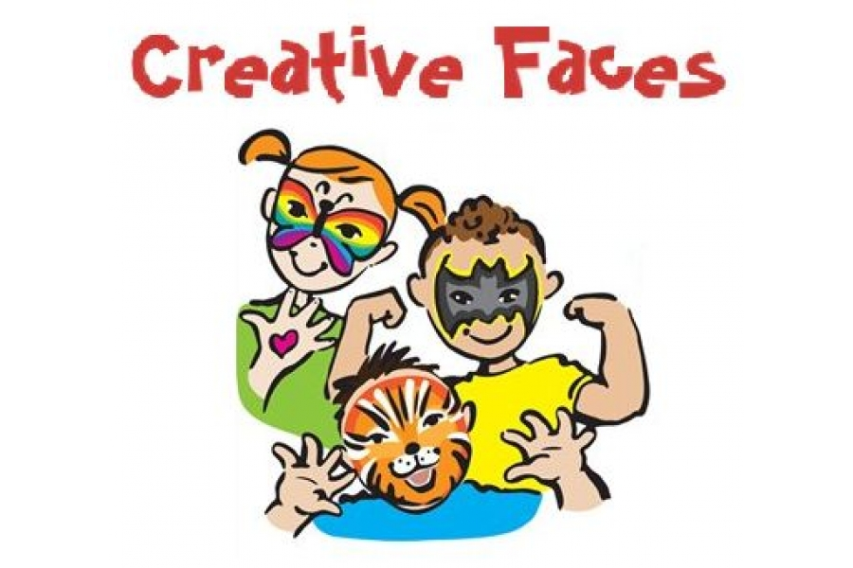

We will also have FACE PAINTING for 50p

If you have any questions or wish to talk to your child’s teacher then please make an appointment at our Reception desk.

