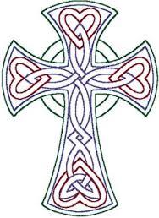
Finbar's
Catholic Primary School
S


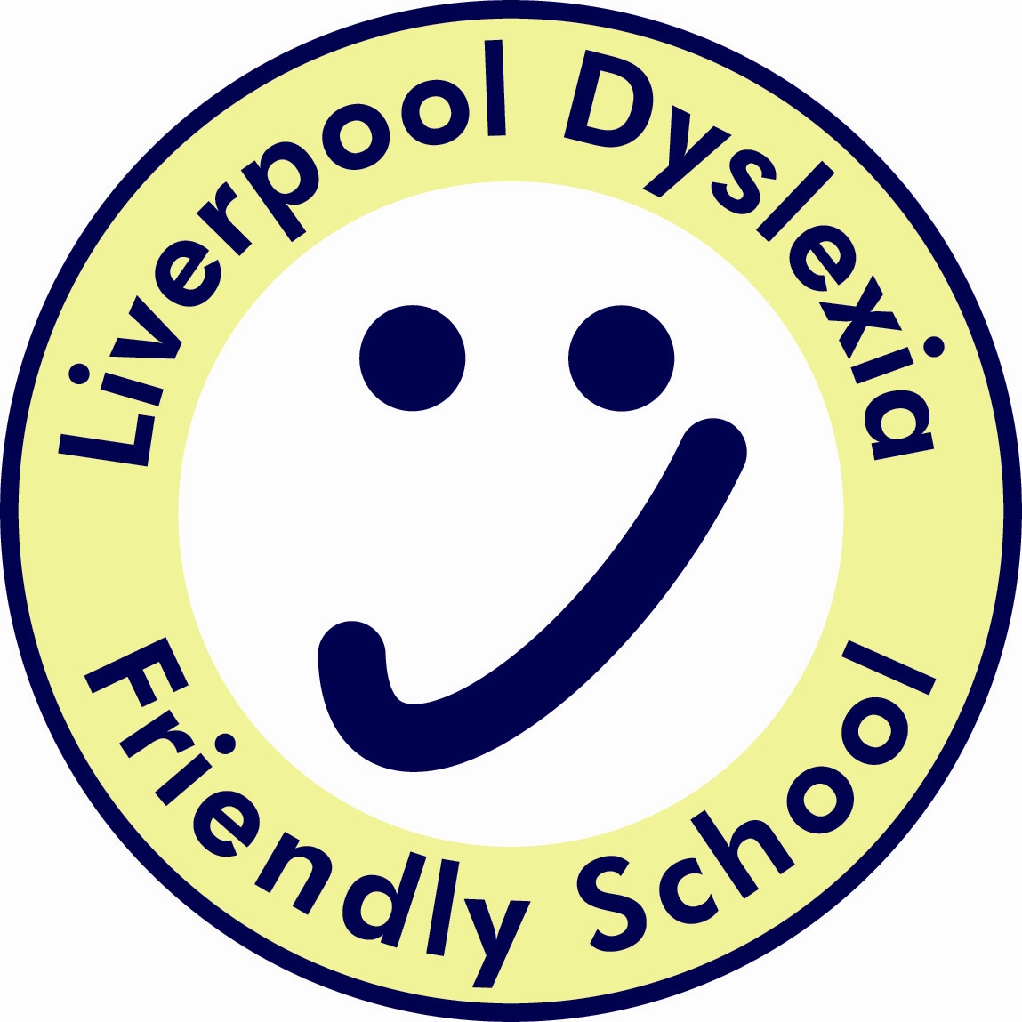



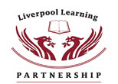

Moral Education Policy
2016/17

Coordinator: Miss L Haresnape

SUB COMMITTEE RESPONSIBLE - CURRICULUM

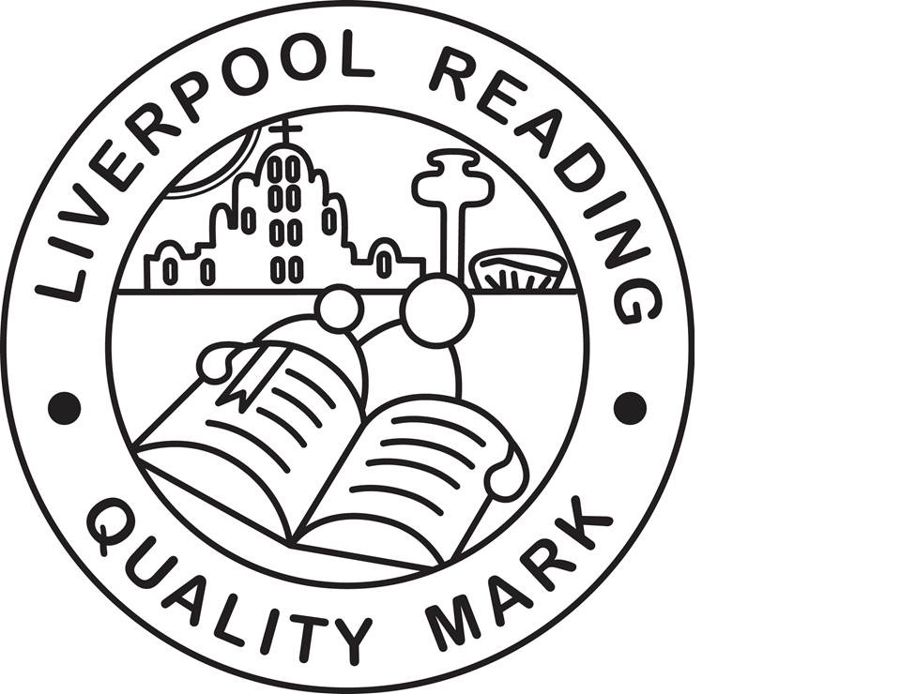

Mission Statement

We at St Finbar’s aim to respect and value all those involved
in contributing to the life of our school.
Our purpose, which is founded upon Catholic
principles, is to provide a secure, happy and creative
environment in which children grow spiritually,
emotionally and intellectually, seeking
and celebrating a personal best.
We promote strong relationships with
families and parish, whilst fostering local
and wider world awareness – creating future
good citizens enabling them to grow
through this Mission in action.

Rationale
Moral education is concerned with developing a child’s ability to distinguish right from wrong, to make appropriate choices and to act upon them from conviction. Personal morality combines the beliefs and value of the individual, those of the social, cultural and religious groups to which he/she belongs and the laws and customs of the wider society.

Purpose
To ensure that pupils understand the difference between right and wrong and the importance of striving to do right. This understanding will:
1. Inform pupils’ thinking and actions and help them exercise their will in resisting temptation;
2. Prompt the constant attempt to become a better person,
3. Increase fellow feeling and the willingness to make an effort to understand others;
4. Build pupils’ respect for themselves, others, their society and their environment;
5. Enable pupils to engage in effective moral reasoning;
6. Help pupils see that weakness, failure and fault belong to the human condition, but we should try to overcome them.
Broad Guidelines
All adults should have:
- humility and willingness to question their own beliefs and actions;
- confidence in themselves;
- general goodwill and concern for their pupils;
- willingness to review their actual and potential contribution to pupils’ moral development;
- a commitment to making that contribution
In order to promote pupils moral development, it is essential that the values of St Finbar’s Catholic Primary School are shared with pupils.

Moral education will be promoted by:
1. Fostering positive school values which include:
- honesty
- reliability
- respecting the rights and property of others
- acting considerably and courteously towards others
- helping those less fortunate or weaker
- taking personal responsibility for one’s actions
- self-discipline

2. Rejecting and reflecting upon negative attitudes which include:
- bullying
- dishonesty and cheating
- deceit
- cruelty
- irresponsibility

For additional guidance please see the Behaviour Policy and the Anti Bullying
Policy

