[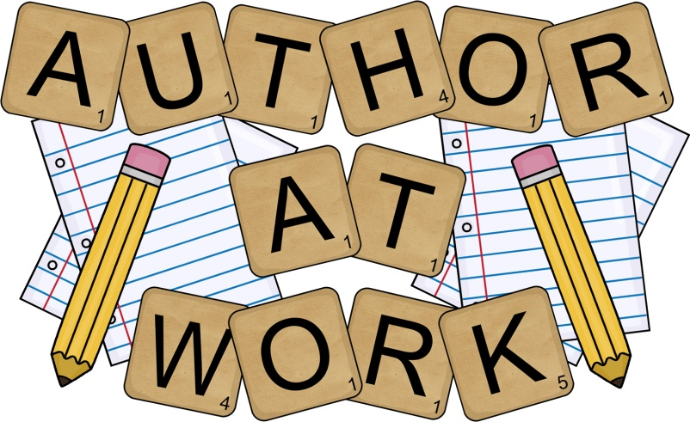](http://www.google.co.uk/url?sa=i&rct=j&q=&esrc=s&source=images&cd=&cad=rja&uact=8&ved=0ahUKEwiM5ZirsMzKAhUD7xQKHYmtAx8QjRwIBw&url=http://www.clipartpanda.com/categories/kids-writing-clip-art-black-and-white&psig=AFQjCNFWSMPX2vnfyFnOSk1qBJom9n-4dw&ust=1454066024156672)Our ref: JPC/MK

Your ref:

September 2017

Dear Parents

Your child has been selected to attend a More Able Writer’s Day at Liverpool College Preparatory School, Mossley Hill, **on Tuesday 26th September.** The author running this event is brilliant fiction writer, poet, and illustrator Chris White. *(Books will be on sale should you wish to buy one at £5.99 each– this is totally optional and you are under no obligation).*

His workshops are lots of fun as well as being educational.

We will be leaving school at 9:00am so please ensure your child is on time.

Your child will need a packed lunch for this day. If they are entitled to a free school dinner please fill in the attached slip and we will provide your child with a school lunch. We will return for the end of the school day.

If you have any questions then please speak to Miss Connor.

Yours sincerely

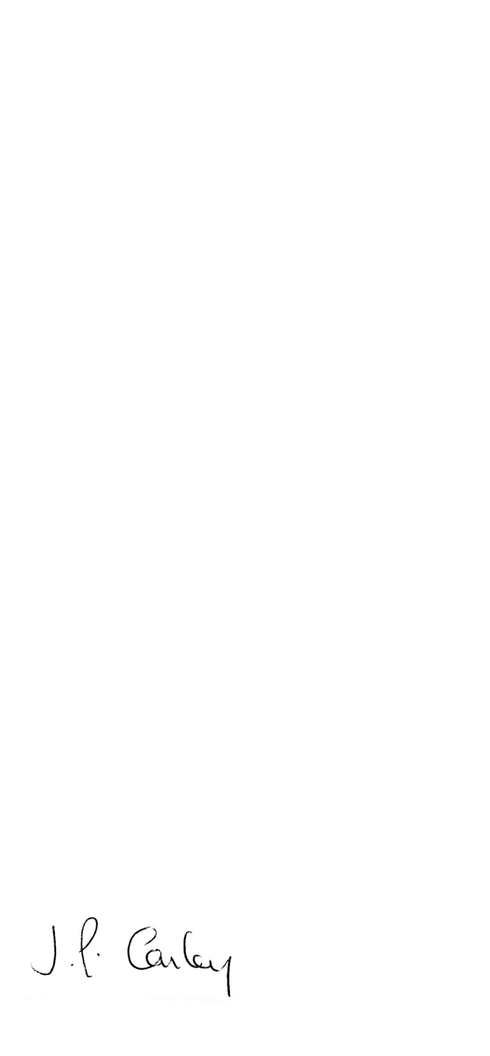

Mrs J P Conley

Headteacher

St Finbar’s Catholic Primary School

RE: Able Writers Day

Name of child: Class: Y

I agree my child can take part in this trip.

My child receives Free School Meals and I would like to order a school packed lunch

***or***

I would like to order a school packed lunch and enclose £2

Signed Parent/Carer

St Finbar’s Catholic Primary School

RE: Able Writers Day

Name of child: Class:

I agree my child can take part in this trip.

My child receives Free School Meals and I would like to order a school packed lunch

***or***

I would like to order a school packed lunch and enclose £2

Signed Parent/Carer