Our ref: JPC/MK
Attendance at an after-school club will count towards Children’s University graduation.
Your ref:

September 2017

Dear Parent/Carer
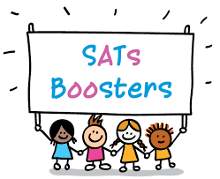
As you will be aware, your child is required to sit end of Key Stage 2 statutory assessments (SATS) during the week beginning 14th May.
These tests are very important as children’s results and scores are passed on to their secondary school.
In order to ensure that we support children to perform to the best of their ability we will be holding SATs revision classes for Mathematics, Reading, Spelling and Grammar every Monday.

These booster sessions will start at 3:15 p.m. until 4:15 p.m starting next Monday 18th September.

Previous years have shown us that children who attended Booster classes, did significantly better in their SATs tests, and were more prepared for the Year 7 curriculum. This fantastic opportunity will be beneficial to your child and will be run by the Year 6 team. We cannot stress enough how valuable these sessions are and hope your child will join us.

If you have any queries please see Miss Melia.

Yours sincerely


Mrs J P Conley
Headteacher

