Our ref: JPC/MK
Your ref:

21 September 2017

Dear Parents & Carers

As part of working towards our Healthy Schools Award we have a guest speaker coming into school to talk about the benefits of travelling to places by bus. Children would like to invite you along to our Assembly on this topic – details are below.
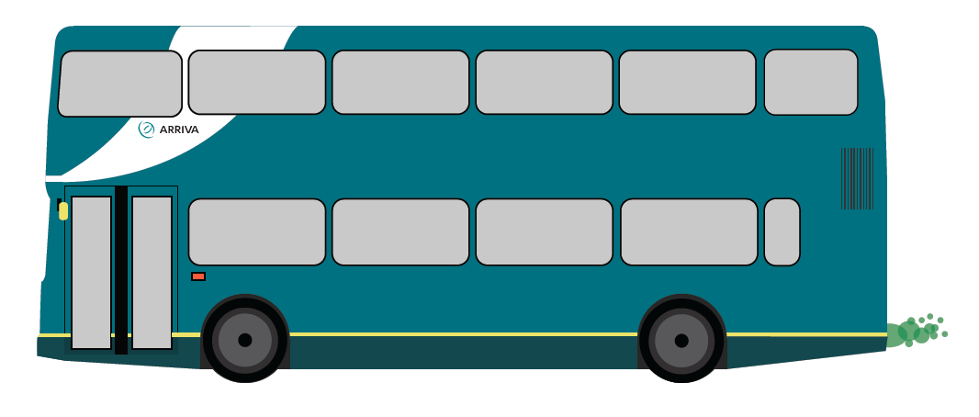

If you have any questions, please see Miss Connor.

Yours sincerely

Mrs J P Conley
Headteacher

