Our ref: JPC/MK
Attendance at an after-school club will count towards Children’s University graduation.
Your ref:
:
September 2017
Football Training

Boys & Girls

Years 4, 5 & 6

Dear Parents/Carers

After School Football Training sessions for Years 4, 5 & 6 will begin next Tuesday 19th September from 3:15 until 4:15 p.m. Mr Millington will run the sessions.

Children will need their PE kit or track suit and trainers.
They will also need a bottle of water.

Please note the children who are chosen must be committed to turning up each week or risk losing their place.

Parents and Carers are asked to complete and return the slip attached indicating home time arrangements. Please bear in mind how dark it will be after half term – you may consider collecting your child for safety reasons.

The charge for a half term is £5 per child to be paid upfront.

Yours sincerely
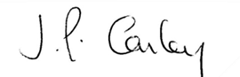

Mrs J P Conley
Headteacher

