Our ref: JPC/MK
Harvest Time Collection
& Celebration
Your ref:

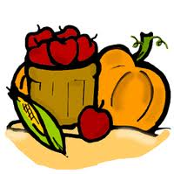
September 2017

Autumn is the season of harvest and the time of year when we give thanks for the food we eat and consider those who are less fortunate than ourselves.

This year, we are going to celebrate harvest with a short collective worship and hamper donations to our local Food Banks.
Years 1 & 2 will lead our celebration assembly on Friday 13th October at 9.15 a.m. Only Year 1 & 2 parents are invited to attend then stay for refreshments afterwards.

We need your help! Please help us to collect food to donate to our local Food Banks. Please choose from the list on the back of this letter and place your item at the collection point in school (or give to your child to bring in) - but please make sure the food is in date and will not go off.
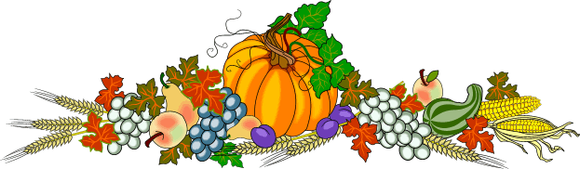
Once collected, we will take the food hampers to the Food Banks to help support those who are struggling.
Thank you for your help and support.

