[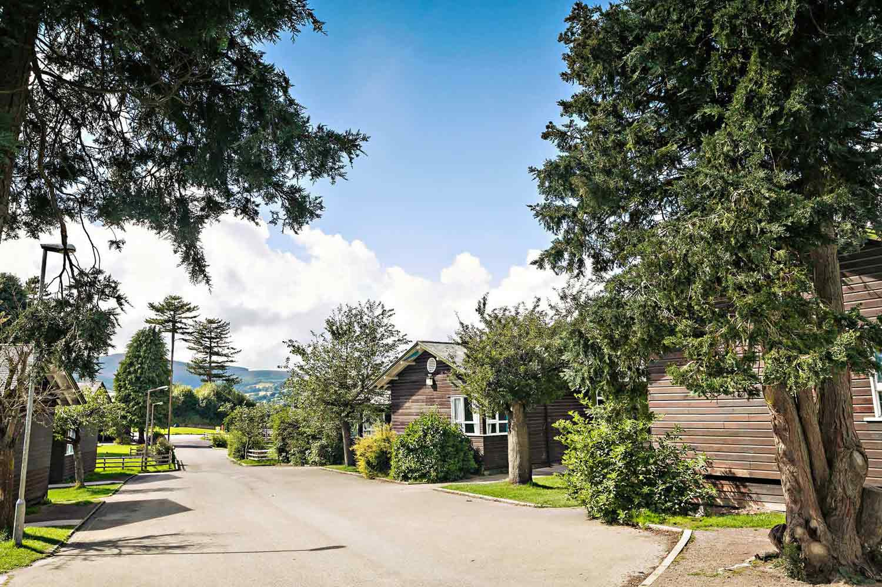](http://www.google.co.uk/url?sa=i&rct=j&q=&esrc=s&source=images&cd=&cad=rja&uact=8&ved=0ahUKEwibt8mU6rXWAhUBNRQKHRyiDBoQjRwIBw&url=http://www.kingswood.co.uk/locations/colomendy/&psig=AFQjCNEkthX8p9EJ9zrYgH1FI7BwAC77nA&ust=1506067861260569)Our ref: JPC/MK

Your ref:

21 September 2017

Dear Parents/Carers

We have arranged a residential trip to Kingswood Colomendy for our Year 6 class next year (Wednesday 28th February to Friday 2nd March).

The total cost of the trip is £100 – and we would require **£20 deposit to be paid by 20th October 2017**.

Instalments can be paid up to the time of the trip to our Reception staff who will issue you with a payment card.

After paying your deposit - you may consider paying a few pounds each week until the final payment which is due on**31st January 2018** which may seem a long way off but will be here before you know it!

Please complete and return the slip below along with your deposit of £20.

*Please note Kingswood will not refund first deposits.*

Yours sincerely

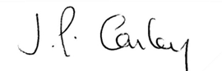

Mrs J P Conley

Headteacher



KINGSWOOD COLOMENDY TRIP

Name of Child: Year 6

I would like my child to take part in this Colomendy trip and enclose a

non-refundable deposit of £20.

Signed: Date: