
Finbar's
Catholic Primary School
S


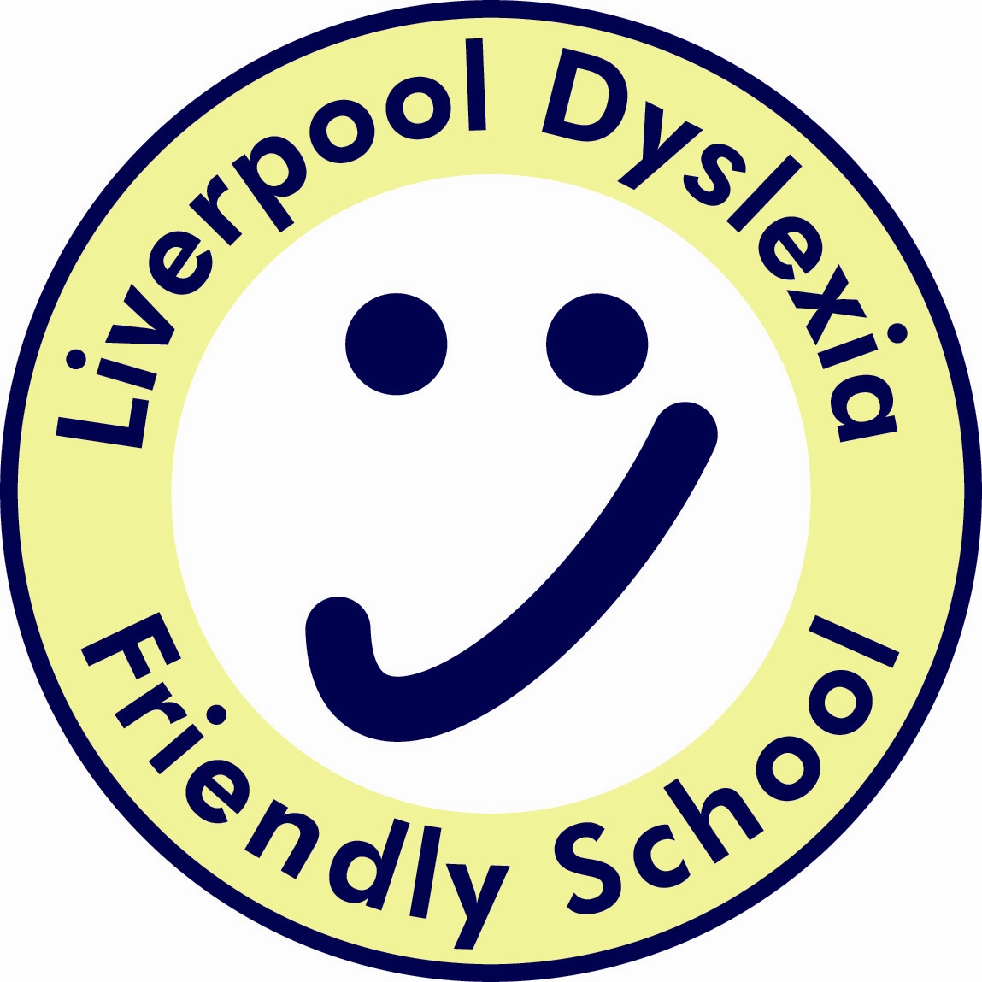



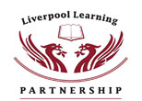

Spiritual Education Policy
2016/17

Coordinator: Miss L Haresnape

SUB COMMITTEE RESPONSIBLE - CURRICULUM

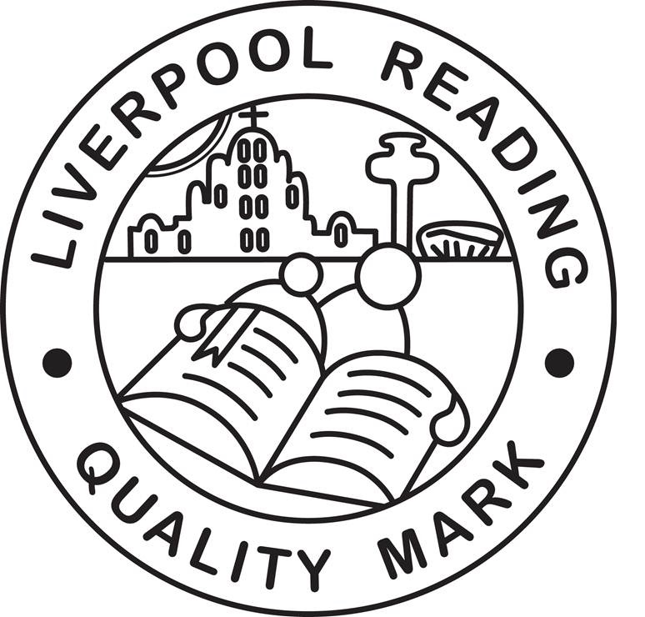

Mission Statement

We at St Finbar’s aim to respect and value all those involved
in contributing to the life of our school.
Our purpose, which is founded upon Catholic
principles, is to provide a secure, happy and creative
environment in which children grow spiritually,
emotionally and intellectually, seeking
and celebrating a personal best.
We promote strong relationships with
families and parish, whilst fostering local
and wider world awareness – creating future
good citizens enabling them to grow
through this Mission in action.

Rationale
Spiritual development is fundamental to the development of the individual. It is not confined to religious beliefs, although we, as a Catholic school, seek to help the development of a personal belief. It seeks to foster curiosity without which there would be no motivation to learn, self-understanding and relationships with other people without which we cannot function in society, a sense of awe, wonder and creativity and the search for means and purpose in life.

Purpose
To ensure that pupils’ experiences, at least in school, are conducive to spiritual growth so that:
1. Pupils are open and responsive, aware of their self-worth, uniqueness, identity, gifts and talents and are able to celebrate their own and others’ achievements;
2. Pupils are trusting, in themselves, in others and in God;
3. Pupils are willing to engage, to take responsibility and to do what is right with courage and hope;
4. Pupils will be able to love others, be generous in spirit and respond well to hardship, limitation, frustration and loss.
5. Pupils have a sense of awe, wonder and mystery and an understanding of the quality of silence and awareness.
6. Pupils develop a sense of the Natural World; dark, light, bread/food, trees, sky, wind, water, earth.

Broad Guidelines
Through our life in school and our curriculum, we will offer:
- Positive and realistic examples;
- Positive role models;
- Opportunities for discussion;
- Support and advice;
- Personal target setting.

Spiritual education will be promoted by developing:
1. An attitude to life based on:
- A development of personal beliefs including religious beliefs;
- An appreciation that people have both individual and shared beliefs on which they base their lives;
- A growing awareness of the way in which personal understanding contributes to personal identity;
- An understanding that one’s inner resources provide the ability to rise above everyday experiences.

2. A sense of awe, wonder and creativity inspired by:
- The natural world
- Mystery
- Human achievement with the arts and science

3. A search for meaning and purpose in life by:
- Developing appropriate responses to the challenging experiences of life such as beauty, suffering and death;
- Being concerned by injustice and aggression and their effect on others;
- A growing awareness of when it is important to control emotions and feelings and how to use such feelings as a source of growth and human experience;

4. Self-awareness and relationships by:
- Developing self-respect;
- Fostering an appreciation of the individuality of others;
- Recognising that every individual has worth;
- Building up relationships with others;
- Fostering a sense of community.

