Our ref: JPC/MK

Your ref:

October 2017

FAO: Year 5 Parents

Dear Parents and Carers

RE: “PROFESSOR FLUFFY”

We have arranged a very interesting and enjoyable day out at Liverpool University for Year 5.

The day is designed for children to get to know all about going to University and an opportunity to look around the campus.

Children will experience a “Graduation” ceremony wearing a cap and gown and will have their photograph taken.

DETAILS:
- Thursday 12th October
- Leave school at 9.15
- School uniform is required
- We aim to return for 3.15 approximately
- Children will need a packed lunch in a throwaway bag please (see other lunch options on the attached reply slip.
- Transport is also provided – no charge

Yours sincerely
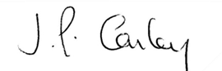

Mrs J P Conley
Headteacher

