**Free School Meals = Equipment and Resources for YOUR School!**

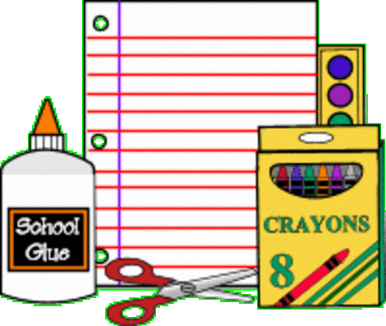**C:\Program Files (x86)\Microsoft Office\MEDIA\CAGCAT10\j0301480.wmf**

Did you know that your school is losing out on additional funding for new equipment and resources?

Did you know that you can help?

Well you can, and here’s how:

You may already know that If your child attends a state funded infant school and is in reception class, year 1 or year 2 (key stage 1) they are entitled to free school meals regardless of your income. This could save you almost **£400 a year** for each child you have in key stage 1.

But, if you apply online, to make a formal application, this will allow your school to claim that additional funding **(pupil premium).**

You can do this online in the section below.

1. Log on to the internet.
2. In the ‘search box’ type in [www.gov.uk](http://www.gov.uk)
3. Click on the Childcare and Parenting option.
4. Click on the Schools and Education option.
5. Scroll down to https: Apply for free school meals option
6. Enter your postcode and click on ‘Find’
7. Click on ‘Go to their website’
8. Click on ‘Apply online’

You can now complete the online form. Please ask your tutor for help if you need it.