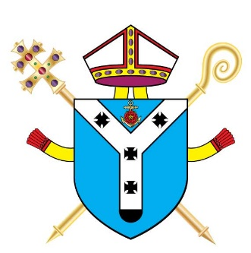
CATHOLIC SCHOOL AND RELIGIOUS EDUCATION

PARENTS’ QUESTIONNAIRE

School:

For each of the statements below, please tick the box which best reflects your views in relation to
the school
My child/ren is/are in year/s ________________

Please tick |  | Strongly  Agree | Agree | Disagree | Strongly  Disagree | Don’t  Know
1 | My child enjoys being at this Catholic school
2 | I am happy with the values and attitudes that the school teaches
3 | I am made to feel welcome in the school
4 | The school seeks the views of parents/carers and takes account of their suggestions and concerns
5 | The school gives me a clear understanding of what is taught in Religious Education
6 | The school enables my child/ren to enjoy and achieve a good standard of work in Religious Education
7 | The school keeps me well informed about my child(ren)’s progress in Religious Education

If you wish to make a comment on any of the above areas please write on the back of this questionnaire. Please do not refer to individual members of staff by name.

Parent’s/Carer’s name: ___________________________

Date: ______________

Thank you for taking the time to fill in this questionnaire.

