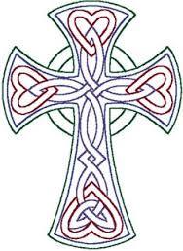
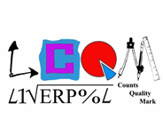
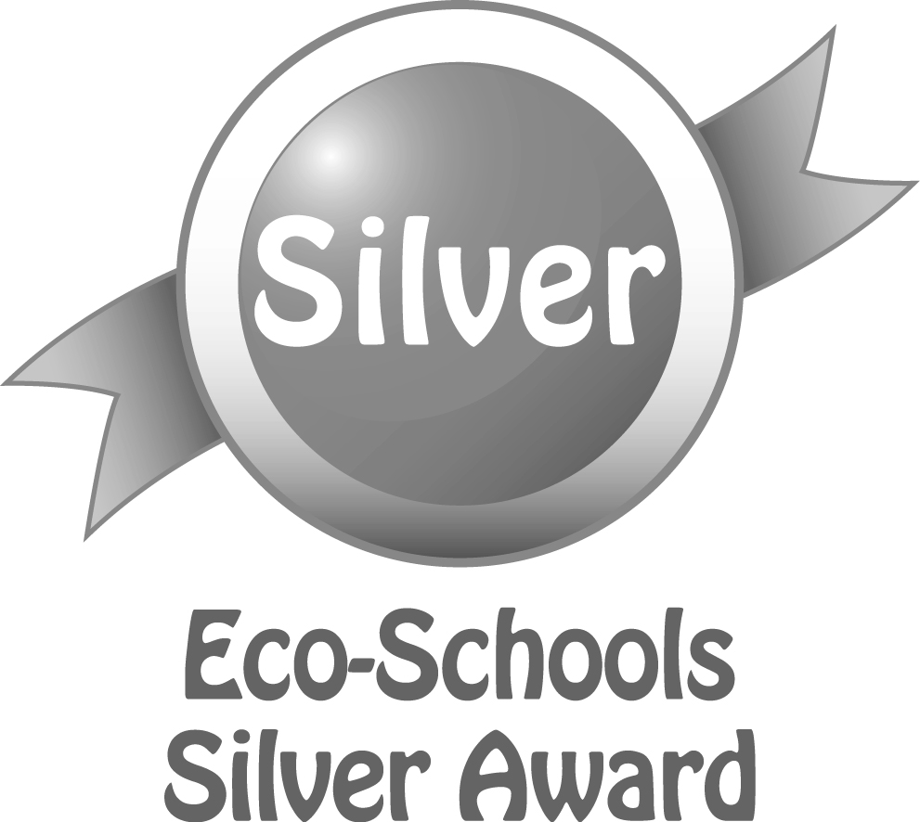
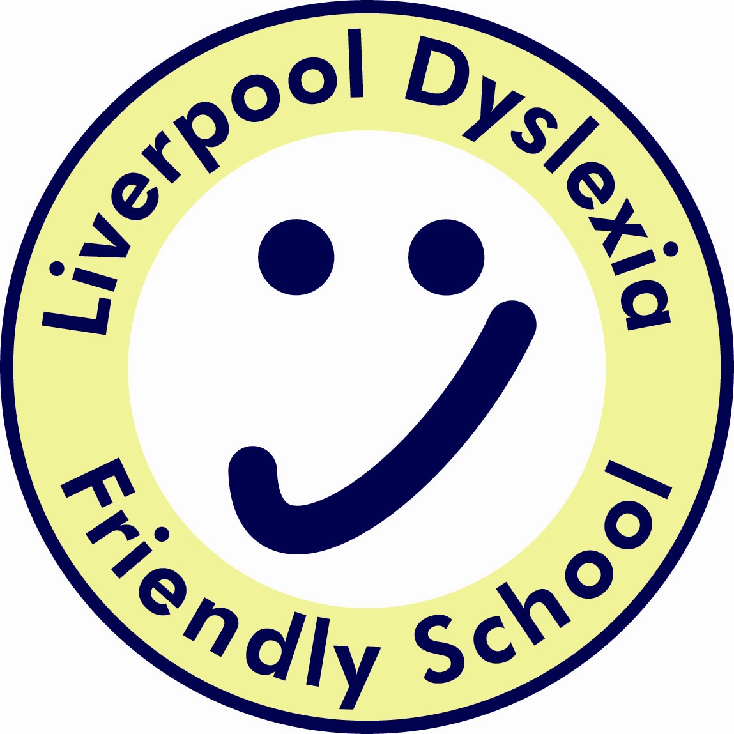
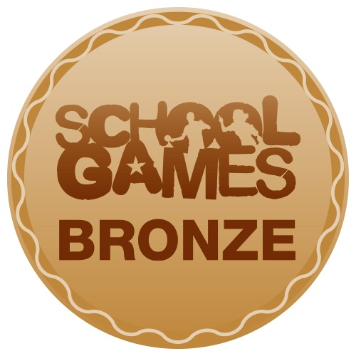
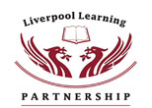
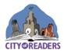
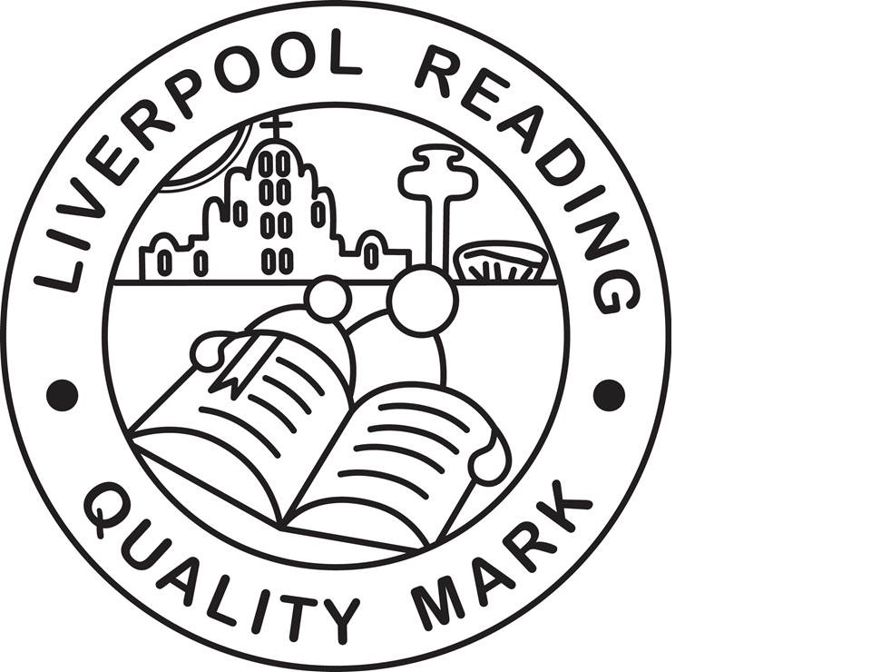
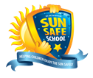
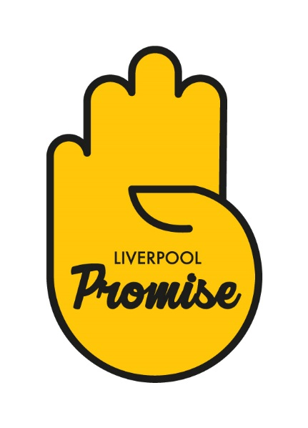
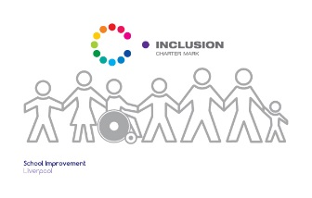
Finbar's
Catholic Primary School
S
Type:
Positional Statement

Art & Design Curriculum Statement:
Intent, Implementation and Impact

Lead:
K Makin
Date:
September 2019

Review date:
September 2020

Art & Design Curriculum Statement;
Intent, Implementation and Impact

September 2019

Introduction

The National Curriculum (2014) sets out what children should be taught in schools across England and Wales. Schools may choose how they organise their school curriculum to cover the programmes of study from years 1 to 6. Children in their reception year follow the Early Years Foundation Stage programmes of learning.

The teaching of Religious Education is statutory in all schools in England and Wales but does not form part of the National Curriculum. As a Catholic school under the trusteeship of the Catholic Archdiocese of Liverpool, RE is taught in accordance with provisions laid out in the programme for primary schools in England and Wales; “Come and See”.

Intent – What we want our learners to get out of studing Art & Design

At St Finbar’s we believe that art, craft and design embody some of the highest forms of human creativity. Our art curriculum is designed so that pupils are engaged, inspired and challenged whilst equipping them with the knowledge and skills to experiment, invent and create their own works of art, craft and design.
As pupils progress within St Finbar’s, they are taught the skills needed to think critically and develop a more rigorous understanding of art and design. Children leave us with an understanding of how art and design both reflect and shape our history, and contribute to the culture, creativity and wealth of our nation.
Children at St Finbar’s will develop their understanding of the visual language of art with effective teaching and considered sequences of lessons. They develop their understanding of the visual elements of art and design (line, tone, texture, colour, pattern, shape, 3D form) through a curriculum which will enable each child to reach their full potential.

Implementation – How we plan and teach Art and Design

We teach a skills-based art curriculum, which gives opportunities for children to express their creative imagination as well as practise and develop mastery in the key processes of art: drawing, painting, printing, textiles and sculpture.

Impact - What we achieve by delivering Art and Design in this way and how we know?

Art contributes to each child’s personal development in creativity, independence, judgement and self-reflection.

