
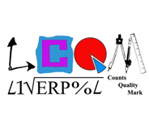

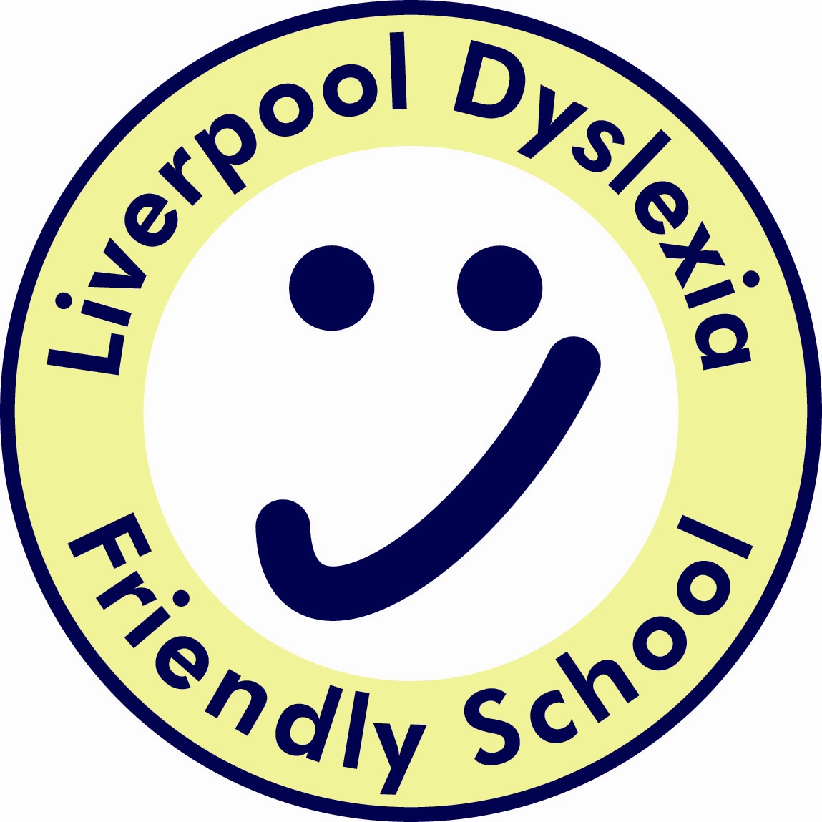
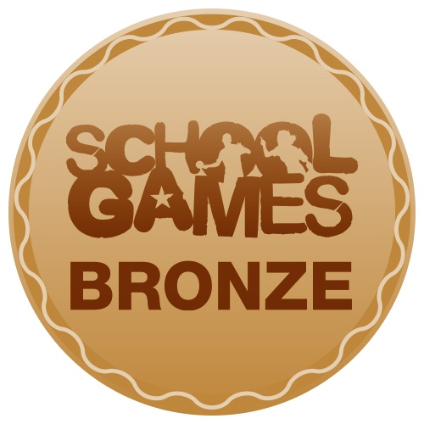


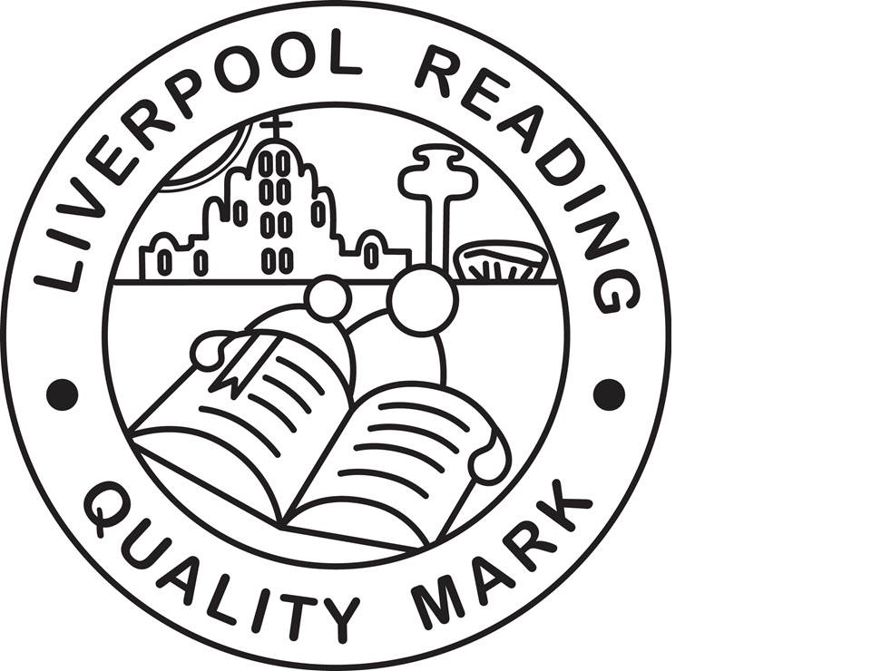


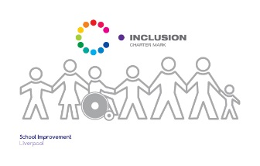
Finbar's
Catholic Primary School
S
Type:
Positional Statement

Computing Curriculum Statement:

Intent, Implementation and Impact

Lead:
Miss C Johnston
Date:
September 2019

Review date:
September 2020

Computing Curriculum Statement;
Intent, Implementation and Impact

September 2019

Introduction

The National Curriculum (2014) sets out what children should be taught in schools across England and Wales. Schools may choose how they organise their school curriculum to cover the programmes of study from years 1 to 6. Children in their reception year follow the Early Years Foundation Stage programmes of learning.

Intent – What we want our learners to get out of studying computing

Our aim is to provide a high-quality computing education which equips children to use computational thinking and creativity to understand and change the world. Our computing curriculum recognises that computing has deep links with mathematics, science and design and technology, and provides insights into both natural and artificial systems.

Implementation – How we plan and teach computing

At St Finbar’s Catholic Primary School, computing is taught using a blocked curriculum approach. This ensures that children are able to develop depth in their knowledge and skills over the duration of each of their computing topics.

Teachers use the ‘Switched On: Computing’ scheme, published by Rising Stars, to inform the planning of their computing lessons. The school has a computing suite and children also have access to a class sets of iPad, ensuring that children can use computers for a range of purposes and that it used across the wider curriculum, as well as in discreet computing lessons. At the core of computing is computer science, in which children are taught the principles of information and computation, how digital systems work and how to put this knowledge to use through programming.

In Key Stage 1 the children will learn to understand what algorithms are; how they are implemented as programs on digital devices; and that programs execute by following precise and unambiguous instructions. They will be taught to create and debug simple programs and use logical reasoning to predict the behaviour of simple programs. They will be shown how to use a range of technology purposefully to create, organise, store, manipulate and retrieve digital content as well as recognise common uses of information technology beyond school. They will be taught to use technology safely and respectfully, keeping personal information private; identify where to go for help and support when they have concerns about content or contact on the internet or other online technologies. Each of these skills will be taught through exciting half termly units.

In Key Stage 2 the children will design, write and debug programs that accomplish specific goals, including controlling or simulating physical systems; solve problems by decomposing them into smaller parts. They will use sequence, selection, and repetition in programs, use logical reasoning to explain how some simple algorithms work and correct errors in algorithms and programs. Children will be taught to understand computer networks, including the internet, and the opportunities they offer for communication and collaboration. They will use search technologies effectively, learn to appreciate how results are selected and ranked, and be discerning in evaluating digital content. Children will be taught to select, use and combine a variety of software (including internet services) on a range of digital devices to create a range of programs, systems and content that accomplish given goals. They will use technology safely, respectfully and responsibly; recognise acceptable/unacceptable behaviour; identify a range of ways to report concerns about content and contact.

Even our children in Early Years provision will be exposed to the understanding of internet safety as they explore the world around them and how technology is an everyday part of their learning and understanding of the world.

Impact - What we achieve by delivering computing in this way and how we know?

After the implementation of this robust computing curriculum, children at St Finbar’s Catholic Primary School will be digitally literate and able to join the rest of the world on its digital platform. They will be equipped, not only with the skills and knowledge to use technology effectively and for their own benefit, but more importantly – safely. The biggest impact we want on our children is that they understand the consequences of using the internet and that they are also aware of how to keep themselves safe online.

As children become more confident in their abilities in Computing, they will become more independent and key life skills such as problem-solving, logical thinking and self-evaluation become second nature.

