
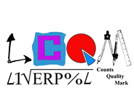





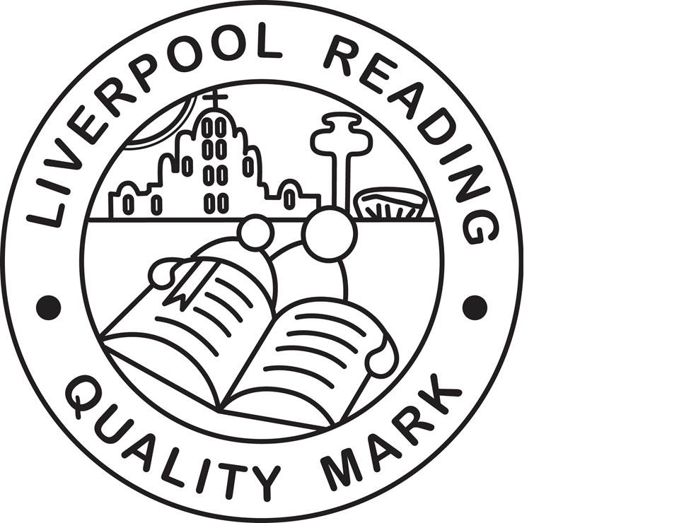


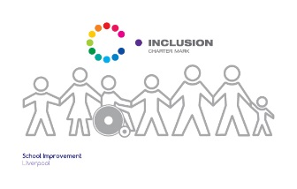
Finbar's
Catholic Primary School
S
Type:
Positional Statement

Design & Technology Curriculum Statement:
Intent, Implementation and Impact

Lead:
K Makin
Date:
September 2019

Review date:
September 2020

Art & Design Curriculum Statement;
Intent, Implementation and Impact

September 2019

Introduction

The National Curriculum (2014) sets out what children should be taught in schools across England and Wales. Schools may choose how they organise their school curriculum to cover the programmes of study from years 1 to 6. Children in their reception year follow the Early Years Foundation Stage programmes of learning.

The teaching of Religious Education is statutory in all schools in England and Wales but does not form part of the National Curriculum. As a Catholic school under the trusteeship of the Catholic Archdiocese of Liverpool, RE is taught in accordance with provisions laid out in the programme for primary schools in England and Wales; “Come and See”.

Intent – What we want our learners to get out of studing Art & Design

Design and Technology is an inspiring, rigorous and practical subject. Design and Technology encourages children to learn to think and intervene creatively to solve problems both as individuals and as members of a team. At St Finbar’s, we encourage children to use their creativity and imagination, to design and make products that solve real and relevant problems within a variety of contexts, considering their own and others’ needs, wants and values. We aim to, wherever possible, link children’s learning too other disciplines such as mathematics, science, engineering, computing and art to deepen children’s knowledge and understanding. The children are also given opportunities to reflect upon and evaluate past and present design technology, its uses and its effectiveness and are encouraged to become innovators and risk-takers.

Implementation – How we plan and teach Art and Design

Through a variety of creative and practical activities, we teach the knowledge, understanding and skills needed to engage in an iterative process of designing and making. The children work in a range of relevant contexts (for example home, school, leisure, culture, enterprise, industry and the wider environment).
When designing and making, the children are taught to:
Design:
Use research and develop design criteria to inform the design of innovative, functional, appealing products that are fit for purpose, aimed at particular individuals or groups.
Generate, develop, model and communicate their ideas through discussion, annotated sketches, cross-sectional diagrams, prototypes, pattern pieces and computer-aided design
Make
Select from and use a wider range of tools and equipment to perform practical tasks (for example, cutting, shaping, joining and finishing) accurately.
Select from and use a wider range of materials and components, including construction materials, textiles and ingredients, according to their functional properties and aesthetic qualities.
Evaluate
Investigate and analyse a range of existing products.
Evaluate their ideas and products against their own design criteria and consider the views of others to improve their work.
Understand how key events and individuals in design and technology have helped shape the world.
Technical knowledge
Apply their understanding of how to strengthen, stiffen and reinforce more complex structures.
Understand and use mechanical systems in their products.
Understand and use electrical systems in their products.

Impact - What we achieve by delivering Art and Design in this way and how we know?

We ensure the children:
Develop the creative, technical and practical expertise needed to perform everyday tasks confidently and to participate successfully in an increasingly technological world.
Build and apply a repertoire of knowledge, understanding and skills in order to design and make high-quality prototypes and products for a wide range of users and critique, evaluate and test their ideas and products and the work of other.
Understand and apply the principles of nutrition and learn how to cook.
Children will design and make a range of products. A good quality finish will be expected in all design and activities made appropriate to the age and ability of the child

