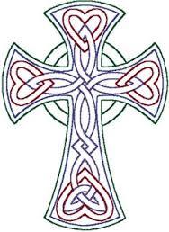
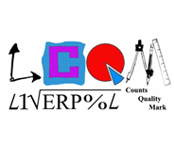

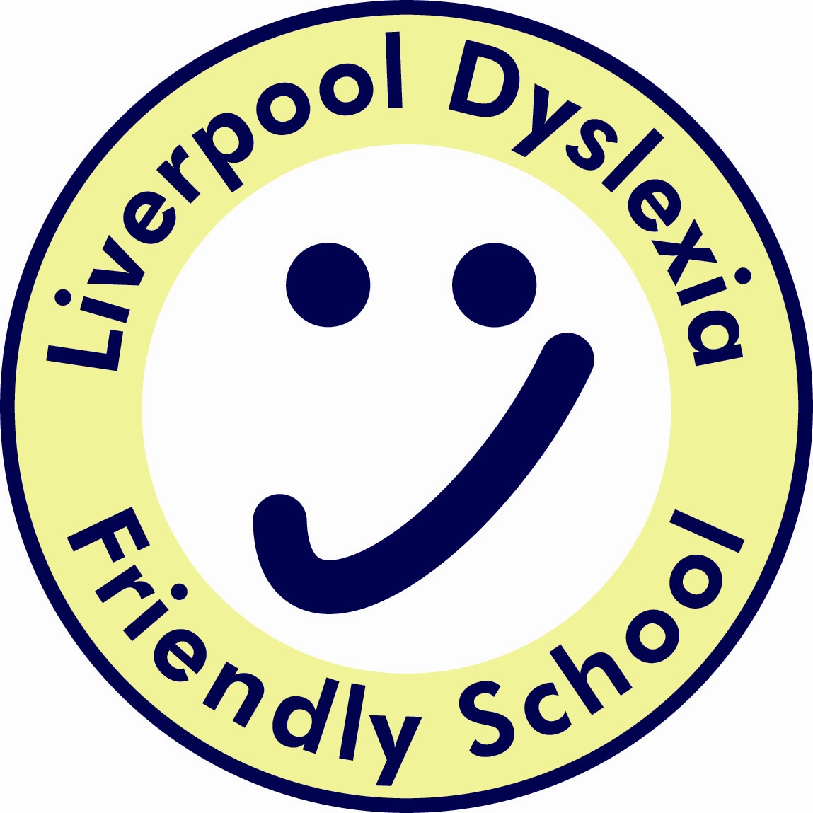



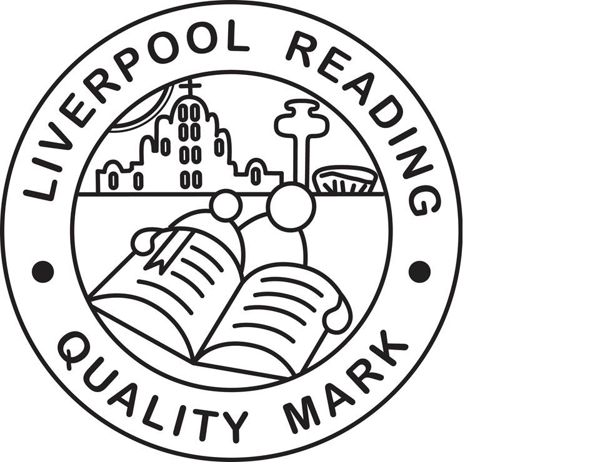


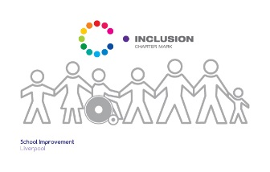
Finbar's
Catholic Primary School
S
Type:
Positional Statement

MFL Curriculum Statement:

Intent, Implementation and Impact

Lead:
Miss Ferguson
Date:
September 2019

Review date:
September 2020

MFL Curriculum Statement;
Intent, Implementation and Impact

September 2019

Introduction

The National Curriculum (2014) sets out what children should be taught in schools across England and Wales. Schools may choose how they organise their school curriculum to cover the programmes of study from years 1 to 6. Children in their reception year follow the Early Years Foundation Stage programmes of learning. The teaching of Modern Foreign Languages is statutory in all schools in England and Wales for Key Stage 2 children.

Intent – What we want our learners to get out of studying MFL

St Finbar’s delivers an inclusive and high quality Modern Foreign Language (MFL) education, which aims for children to understand and respond to the spoken and written language, to communicate effectively, both in speaking and writing. The MFL curriculum allows children to recognise patterns and sounds and engage in conversations, using accurate pronunciation. MFL encourages children to broaden their vocabulary and enables them to use the skills they have learnt in real life. We provide a languages education that fosters pupils’ curiosity and deepens their understanding of the world.

Implementation – How we plan and teach MFL

At St Finbar’s we deliver a scheme of learning in MFL that meets the National Curriculum requirements issued by the DfE. The school employs a specialist MFL teacher, to work across the KS2 classes. These lessons are delivered on a weekly basis, lasting 30 minutes per session. The children develop subject-specific skills and vocabulary during their lessons and they build upon their prior learning and recap each week so that the children’s knowledge is secure. MFL is also promoted throughout the school, through afternoons dedicated to specific topics e.g. In December, we looked at Christmas traditions around the world. We also use displays to celebrate the work completed in MFL sessions, key vocabulary is present in classrooms and staff make use of any opportunities to include our studied language into our daily routines e.g. registers. We try to incorporate MFL into other curriculum areas such as DT when we are creating local dishes from different countries and Geography when we compare different regions of the world. MFL planning ensures the development of all four key skills areas (listening, reading, speaking and writing) and planning is sequenced to promote progression in terms of age-related expectations.

Impact - What we achieve by delivering MFL in this way and how we know?

- Impact is monitored in a variety of ways to cover all four key skills such as teacher judgement, videos, summative assessment sheets and a monitoring system to see how children are progressing through age-related expectations.
- Pupil voice and self-assessment sheets show that the children thoroughly enjoy and engage with the MFL lessons.
- The half termly activity sheets show that the children have retained and can apply their knowledge and skills learnt throughout their sessions.
- The children enjoy using their MFL learning in other areas of the curriculum and outside of school.
- The children acquire foreign language skills that they can apply in real life situations.

