
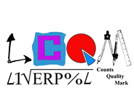





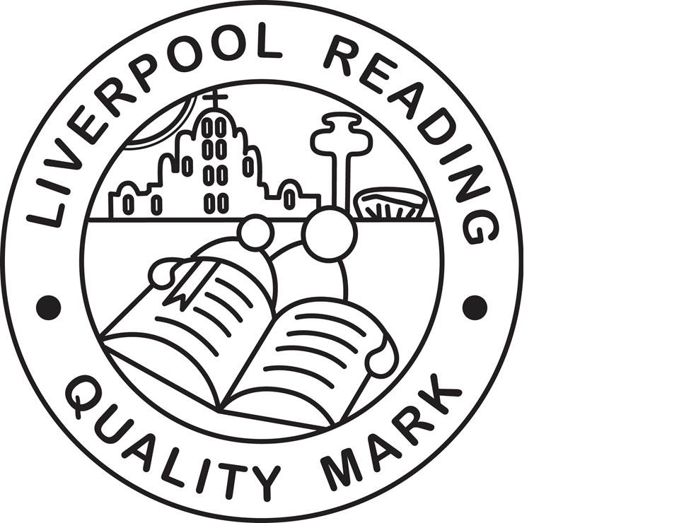


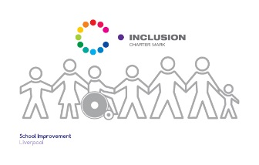
Finbar's
Catholic Primary School
S
Type:
Positional Statement

Maths Curriculum Statement:

Intent, Implementation and Impact

Lead:
Mrs C Flynn
Date:
September 2019

Review date:
September 2020

Maths Curriculum Statement;
Intent, Implementation and Impact

September 2019

Introduction

The National Curriculum (2014) sets out what children should be taught in schools across England and Wales. Schools may choose how they organise their school curriculum to cover the programmes of study from years 1 to 6. Children in their reception year follow the Early Years Foundation Stage programmes of learning.

The teaching of Religious Education is statutory in all schools in England and Wales but does not form part of the National Curriculum. As a Catholic school under the trusteeship of the Catholic Archdiocese of Liverpool, RE is taught in accordance with provisions laid out in the programme for primary schools in England and Wales; “Come and See”.

Intent – What we want our learners to get out of studing Maths

With the introduction of curriculum 2014 we, at St Finbar’s, have made the transition in teaching methods to what is termed ‘Mastery Teaching’. This style of teaching has revolutionised the way in which maths is taught, learnt and viewed by all in the school. Since their introduction in Summer 2017, everyone is beginning to believe maths is a subject that they can achieve in and many children are being challenged to explore concepts in more depth.
We aim to provide a high-quality mathematics education with a mastery approach so that all children:
• become fluent in the fundamentals of mathematics;
• reason mathematically;
• can solve problems by applying their mathematics.

We incorporate sustained levels of challenge through varied and high quality activities with a focus on fluency, reasoning and problem solving. Children are required to explore maths in depth, using mathematical vocabulary to reason and explain their workings. A rang of mathematical resources are used and pupils taught to show their workings in a concrete fashion, before establishing ways of pictorially and formally representing their understanding. They are taught to explain their choice of methods and develop their mathematical reasoning skills. We encourage resilience and acceptance that struggle is often a necessary step in learning.

Implementation – How we plan and teach Maths
Teaching Maths for Mastery

EYFS
Children are exploring and immersing themselves in maths from Nursery. They are introduced to the basics of maths in a variety of ways. In the Early Years Foundation Stage (EYFS), we relate the mathematical aspects of the children's work to the Development Matters statements and the Early Learning Goals (ELG), as set out in the EYFS profile document. Mathematics development involves providing children with opportunities to practise and improve their skills in counting numbers, calculating simple addition and subtraction problems, and to describe shapes, spaces, and measures. The profile for Mathematics areas of learning are Number (ELG 11) and shape, space and measures (ELG 12). We continually observe and assess children against these areas using their age-related objectives, and plan the next steps in their mathematical development. There are opportunities for children to encounter Maths throughout the EYFS (both inside and outside) – through both planned activities and the self-selection of easily accessible quality maths resources. Whenever possible children’s interests are used to support delivering the mathematics curriculum. Towards the end of Reception teachers aim to draw the elements of a daily mathematics lesson together so that by the time they move to Year 1 they are familiar with the structure with a lesson/activity.

Key Stage One and Two
The whole class works through the White Rose programmes of study at the same pace with ample time on each topic before moving on. The focus within maths lessons is on fluency and not speed. Children are encouraged to think carefully about mathematical problems, discuss and explain their understanding and learn from one another. The result is more fluent mathematicians with a deeper understanding of concepts and their inter-relationships and a group of children that have a firm foundation to build on and a more confident outlook towards the subject.
Pupils who grasp concepts rapidly are challenged through rich and sophisticated problems before any acceleration through new content. Those pupils who are not sufficiently fluent with earlier material should consolidate their understanding, including through additional practice, before moving on.

Concrete, pictorial and abstract – objects, pictures, words, numbers and symbols are everywhere. The mastery approach incorporates all of these to help children explore and demonstrate mathematical ideas, enrich their learning experience and deepen understanding. Together, these elements help cement knowledge so pupils truly understand what they have learnt.

Teaching
- ‘Know where their children are’ through the use of summative assessment, daily lessons and assessment tasks.
- ‘Understand where their children need to be’ through a secure understanding of year group expectations and/or pre key stage expectations and ongoing formative assessment
- ‘Know how they are going to get them there’ through the use of a range of strategies to promote independence, mastery and high expectations of ALL.
- Effectively deploy adults, specifically during introductions, plenaries and catch-up sessions.

Assessment
- Summative/reported - NFER
- Standardisation (YR – Y6)
- Summative/ diagnostic (where necessary) – Liverpool Assessment documents
- Formative / ongoing – * See Marking, Assessment & Feedback policy
- Moderation
  - In-house
  - Cross-school
  - Local authority

Impact - What we achieve by delivering Maths in this way and how we know?

A mathematical concept or skill has been mastered when a child can show it in multiple ways, using the mathematical language to explain their ideas, and can independently apply the concept to new problems in unfamiliar situations.
We use both formative and summative assessment information every day, in every lesson. Staff use this information to inform their short-term planning and short-term interventions. This helps us provide the best possible support for all of our pupils, including the more able.
Our staff use formative assessment grids to systematically assess what the children know as the topic progresses and inform their future planning. These formative assessment grids then inform summative assessment judgements
Assessment information is analysed by Subject Leads, the Assessment Lead and Headteacher as part of our monitoring cycle. Pupil progress reviews are conducted half termly (formative) and termly (summative). This process provides the SLT and Governors with an accurate and comprehensive understanding of the quality of education in our school.
We set out our monitoring cycle at the beginning of each academic year. This identifies when monitoring for all year groups is undertaken in all subject areas. Monitoring includes: book scrutinies, lesson observations and/or learning walks, pupil/parent and/or staff voice.
All of this information is gathered and reviewed. It is used to inform further curriculum developments and provision is adapted accordingly.

