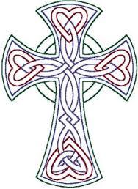
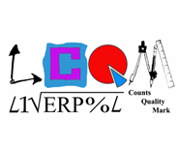
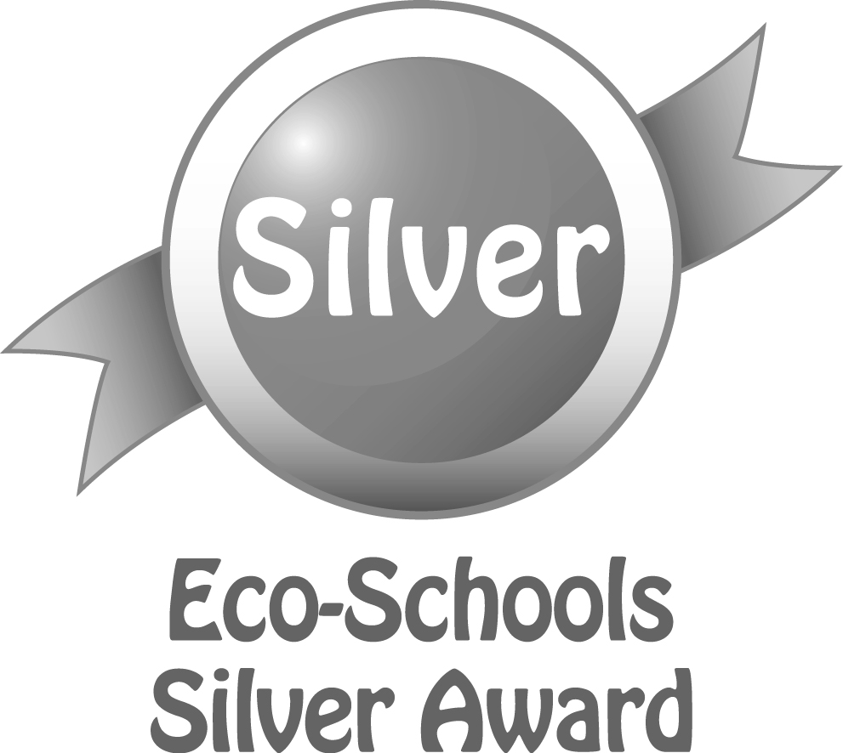
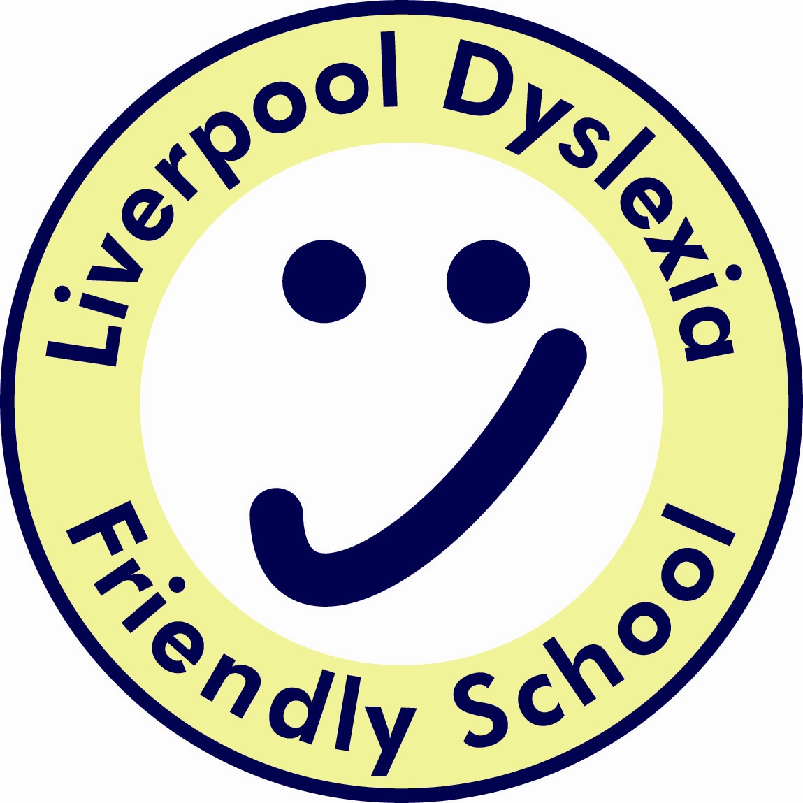
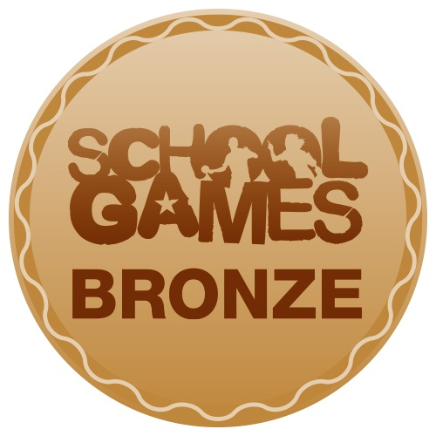
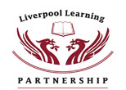

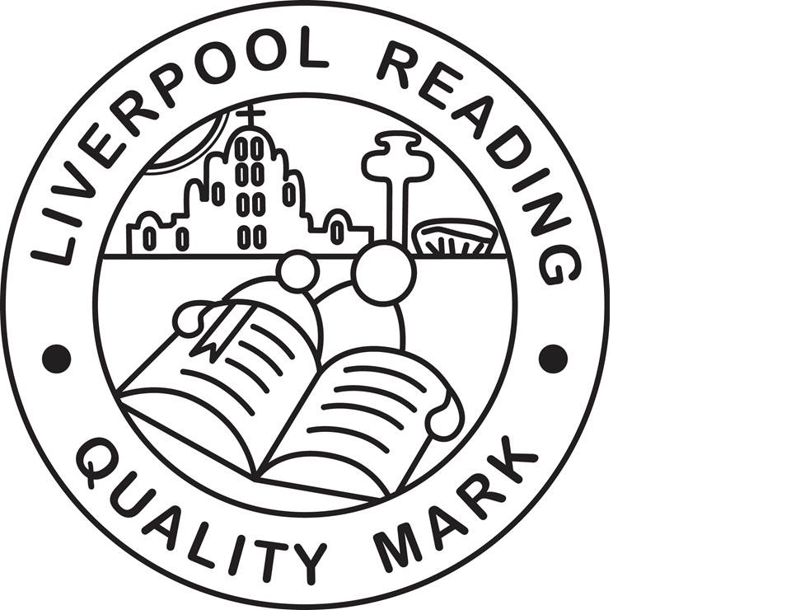

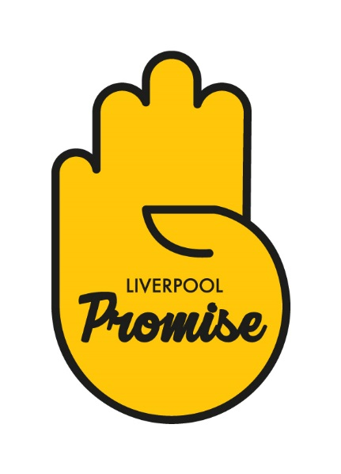
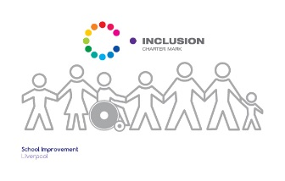
Finbar's
Catholic Primary School
S
Type:
Positional Statement

Music Curriculum Statement:

Intent, Implementation and Impact

Lead:
Miss C Johnston
Date:
September 2019

Review date:
September 2020

Music Curriculum Statement;
Intent, Implementation and Impact

September 2019

Introduction

The National Curriculum (2014) sets out what children should be taught in schools across England and Wales. Schools may choose how they organise their school curriculum to cover the programmes of study from years 1 to 6. Children in their reception year follow the Early Years Foundation Stage programmes of learning.

Intent – What we want our learners to get out of studing Music

The National Curriculum for music aims to ensure that all children:
- perform, listen to, review and evaluate music
- be taught to sing, create and compose music
- understand and explore how music is created, produced and communicated
At St Finbar’s, children gain a firm understanding of what music is through listening, singing, playing, evaluating, analysing, and composing across a wide variety of historical periods, styles, traditions, and musical genres. We are committed to developing a curiosity for the subject, as well as an understanding and acceptance of the validity and importance of all types of music, and an unbiased respect for the role that music may wish to be expressed in any person’s life. We are committed to ensuring children understand the value and importance of music in the wider community and are able to use their musical skills, knowledge, and experiences to involve themselves in music, in a variety of different contexts.

Implementation – How we plan and teach music

The music curriculum ensures children sing, listen, play, perform and evaluate. This is embedded in the classroom activities as well as the weekly singing assemblies, various concerts and performances, the learning of instruments, and the joining of one of our many musical ensembles. The elements of music are taught in the classroom lessons so that children are able to use some of the language of music to dissect it, and understand how it is made, played, appreciated and analysed.

Charanga is a scheme of work which offers a topic-based approach to support children’s learning in music. A steady progression plan has been built into Charanga, both within each year and from one year to the next, ensuring consistent musical development.

By using Charanga as the basis of a scheme of work, we can ensure that they are fulfilling the aims for musical learning stated in the National Curriculum:
- Charanga includes many examples of music styles and genres from different times and places. These are explored through the language of music via active listening, performing and composing activities, which enable understanding of the context and genre.
- Charanga provides a classroom-based, participatory and inclusive approach to music learning. Throughout the scheme, children are actively involved in using and developing their singing voices, using body percussion and whole body actions, and learning to handle and play classroom instruments effectively to create and express their own and others’ music. Through a range of whole class, group and individual activities, children have opportunities to explore sounds, listen actively, compose and perform.

In the classroom children learn how to play an instrument, from all four main instrument groups of brass, wind and tune and untuned percussion. In doing so to understand the different principle of each method of creating notes, as well as how to read basic music notation. They also learn how to compose, focusing on different dimensions of music, which in turn feeds their understanding when listening, playing, or analysing music. Composing or performing using body percussion and vocal sounds is also part of the curriculum, which develops the understanding of musical elements without the added complexity of an instrument.

Impact - What we achieve by delivering music in this way and how we know?

Whilst in school, children have access to a varied programme, which allows them to discover areas of strength, as well as areas they might like to improve upon. The integral nature of music and the learner creates an enormously rich palette from which a child may access fundamental abilities such as: achievement, self-confidence, interaction with and awareness of others, and self-reflection.

Music will also develop an understanding of culture and history, both in relation to children individually, as well as ethnicities from across the world. Children are able to enjoy music in as many ways as they choose – either as listener, creator or performer. They can dissect music and comprehend its parts. They can sing and feel a pulse. They have an understanding of how to further develop skills less known to them, should they ever develop an interest in their lives.

