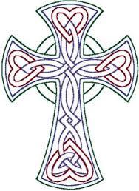
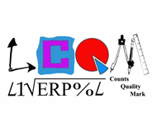
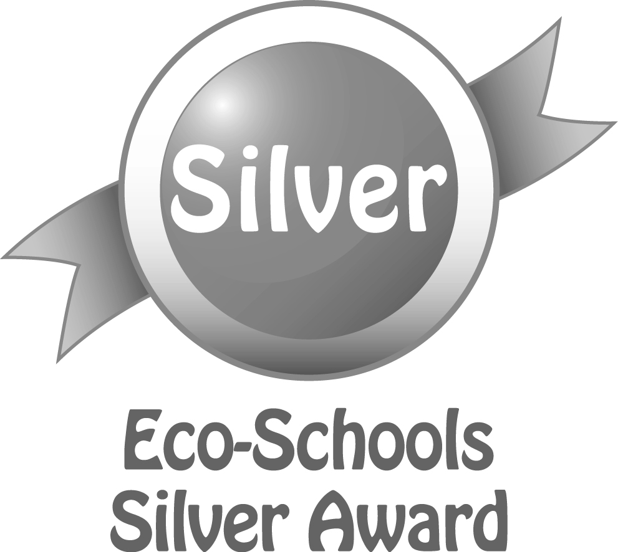
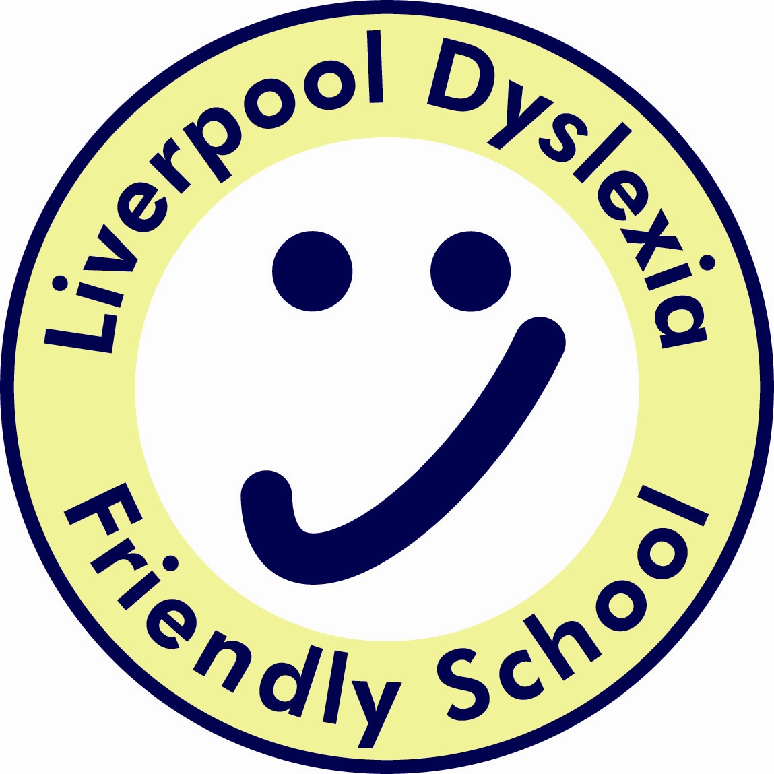
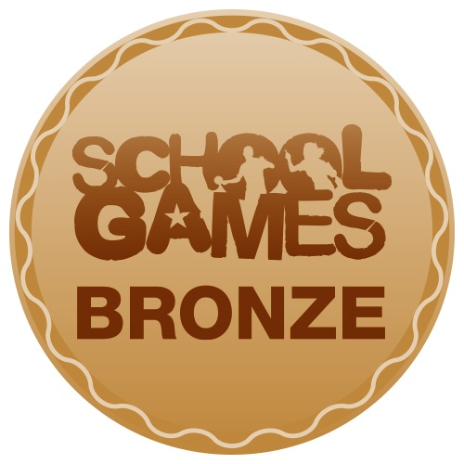
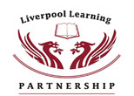

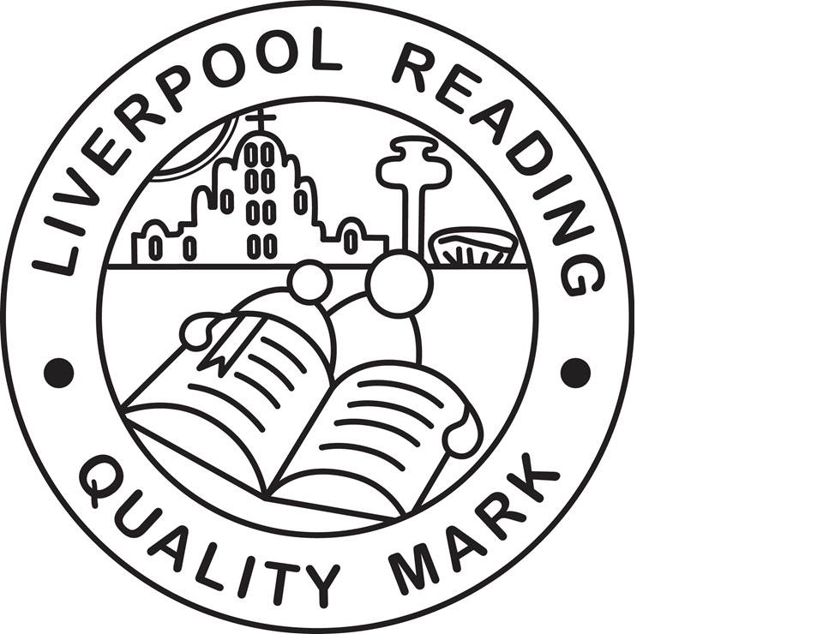

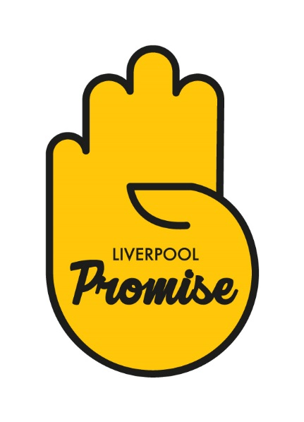
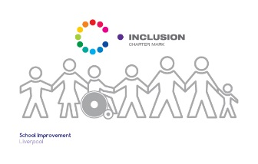
Finbar's
Catholic Primary School
S
Type:
Positional Statement

PSHE Curriculum Statement:

Intent, Implementation and Impact

Lead:
Mrs Aslam
Date:
September 2019

Review date:
September 2020

PSHE Curriculum Statement;
Intent, Implementation and Impact

September 2019

Introduction

The National Curriculum (2014) sets out what children should be taught in schools across England and Wales. Schools may choose how they organise their school curriculum to cover the programmes of study from years 1 to 6. Children in their reception year follow the Early Years Foundation Stage programmes of learning. The teaching of Physical Education is statutory in all schools in England and Wales across all the Key Stages.

Intent – What we want our learners to get out of studying PSHE

In St Finbar’s our aim is to provide all of our children with consistent access to a broad, balanced and high quality physical education which will:
- Benefit health and well being
- Develop their knowledge, skills and experiences across a range of sports
- Enable them to perform at competitive level
- Build the knowledge, skills, values and confidence necessary for them to make positive, healthy decisions throughout their lives.
- Encourage sports participation for life
- Increase social opportunities

Implementation – How we plan and teach PSHE

At St Finbar’s Catholic Primary School, P.E is taught by classroom teachers using a blocked curriculum approach. From EYFS to Key Stage 2 classes are taught dance for two terms by an outside provider. Key Stage 2 are also taught swimming for 10 sessions per class by an outside provider. This ensures that children are able to develop depth in their knowledge and skills over the duration of each of their P.E topics.

Teachers use ‘P.E passport’ Physical Education scheme of work as well as the LSSP My Personal Best and Top Cards to inform the planning of P.E lessons. Children have full access to the P.E hall, outside area and Swimming pool as well as a range of sports resources.

PE is an integral part of our wider Healthy School provision which also includes: Active Lunchtimes and Healthy Lunches.

We offer a range of clubs and activities before, during and after school, led by both teachers and specialist coaches, which are open to all ability levels and which enable pupils to enjoy physical activity and develop self-esteem and confidence in a non-competitive ethos. Some extra- curricular learning activities target pupils who show a particular skill in a sport and provide them with the opportunity to extend their skills in a competitive ethos.

Impact - What we achieve by delivering PSHE in this way and how we know?

After the implementation of this broad and balance P.E curriculum all children will have consistent access to high quality, safe PE lessons which will benefit health and wellbeing as well as developing their knowledge, skills and experiences across a range of sports. It will also enable them to perform at competitive level and build the knowledge, skills, values and confidence necessary for them to make positive, healthy decisions throughout their lives.

