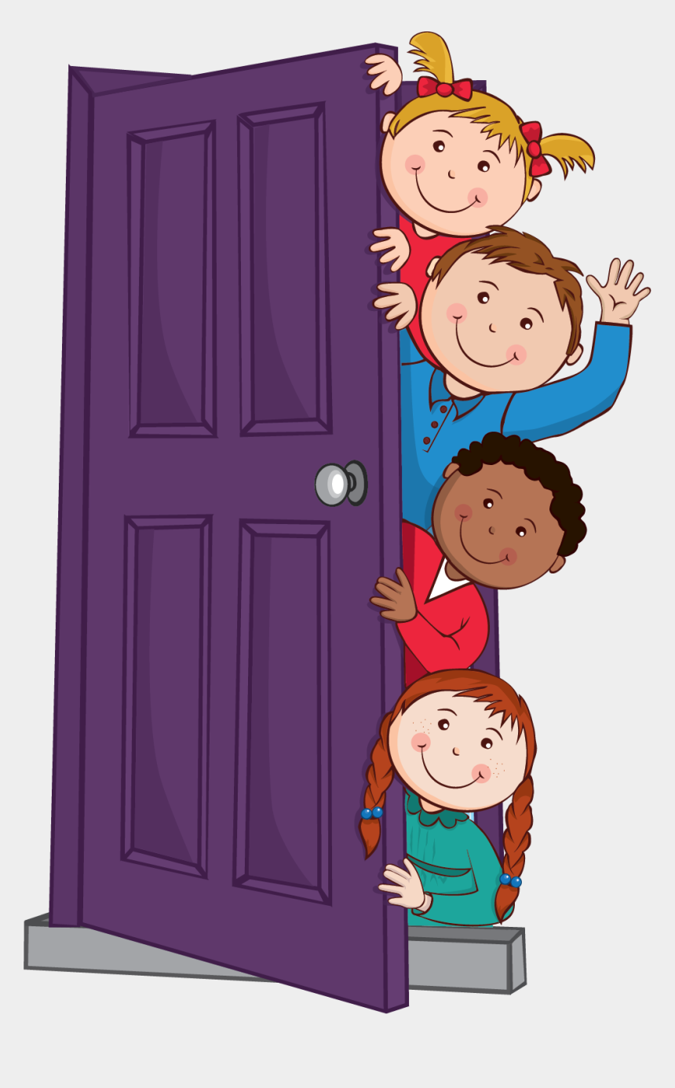

Class | Friendship Award | Special Award
1 | Rosie O’Callaghan | Gregory Booth
2 | Elsa Adloo | Fanuel Andeberhan
3 | Yadiail Araya | Lucie Fitzsimmons
4 | Tiffany He | Megan McNulty
5 | Louie Byrne | Kian Creegan
6 | Kenean Andeberhan | David Kabamba










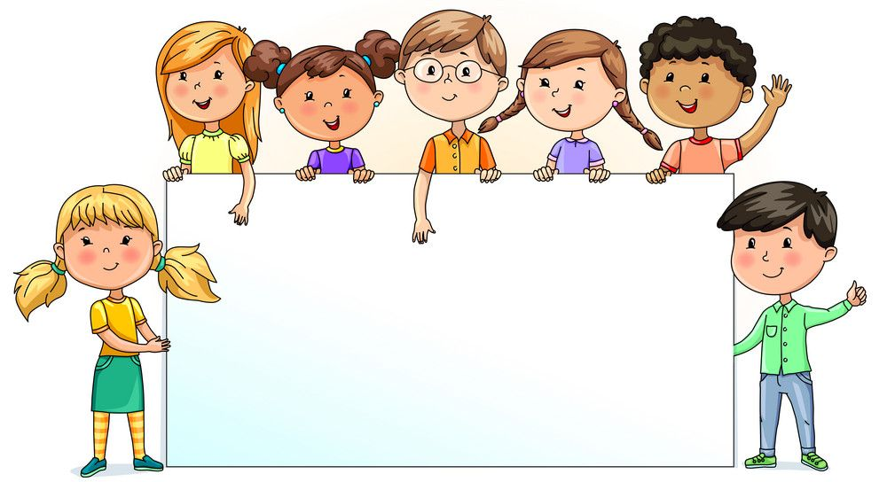

Nursery | Reception | Year 1 | Year 2 | Year 3 | Year 4 | Year 5 | Year 6
82.98% | 84.57% | 94.09% | 98.33% | 100% | 98.57% | 95.17% | 91.18%

