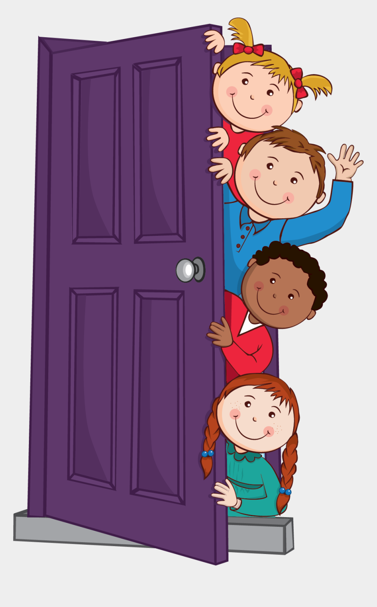

Class | Friendship Award | Special Award
1 | Dottie Lavelle | Ayman Shirrah
2 | Siana Jolla | Andrea Bweya
3 | Fariha Niazi | Kaps Kabamba
4 | Fabian Clements | Scarlett Gallagher
5 | Anna Hachem | Ethan McPartlin
6 | Anthony Tierney | Mason Corner










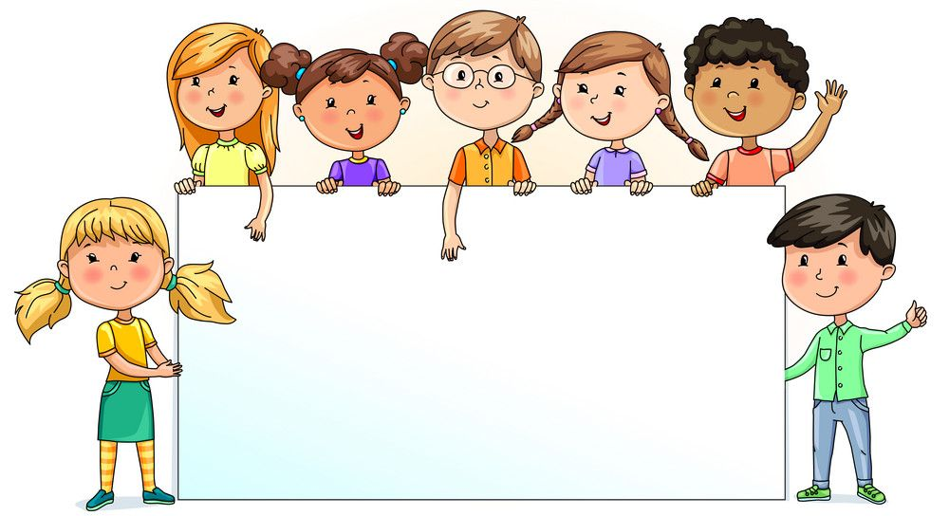

Nursery | Reception | Year 1 | Year 2 | Year 3 | Year 4 | Year 5 | Year 6
93.41% | 95.51% | 97.27% | 96.11% | 98.95% | 97.86% | 96.90% | 96.25%

