

Class | Merit Award | Friendship Award | Special Award
1 | Tasneem Ali | David Conroy | Oliver Donohue
2 | Adam Jaouadi | Leighton Brophy | Luke Moore
3 | Darcie Carney-Feeley | Fariha Niazi | Adam Conroy
4 | Emily Rowlands | Lamisa Toma | Brielle Nosakhare Osawaru
5 | Kaiden Deakin | David Badea | Adam Fitzgibbon
6 | Anthony Tierney | Nawal Mohamoud | Kenean Andeberhan










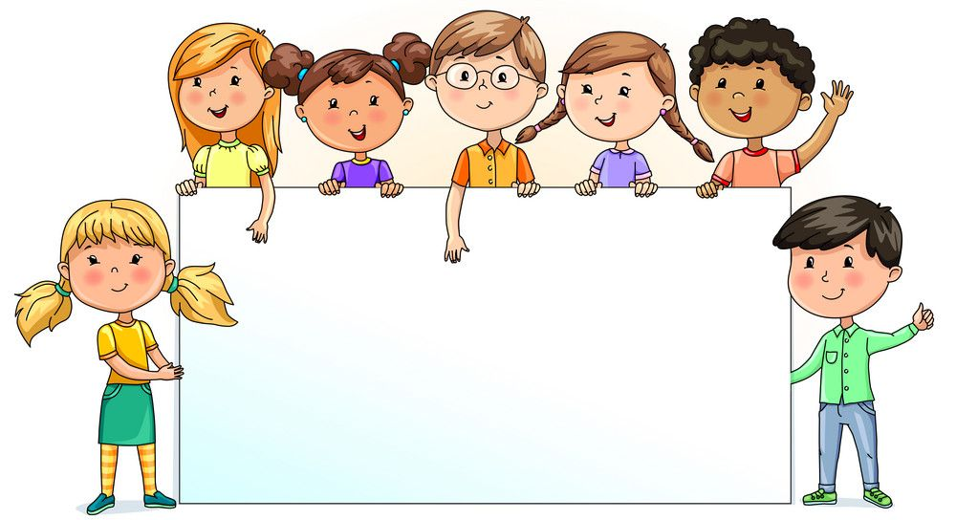

Nursery  79.55% | Reception  80.50% | Year 1  99.05% | Year 2  92.94% | Year 3  91.90% | Year 4  89.64% | Year 5  86.00% | Year 6  82.94%

