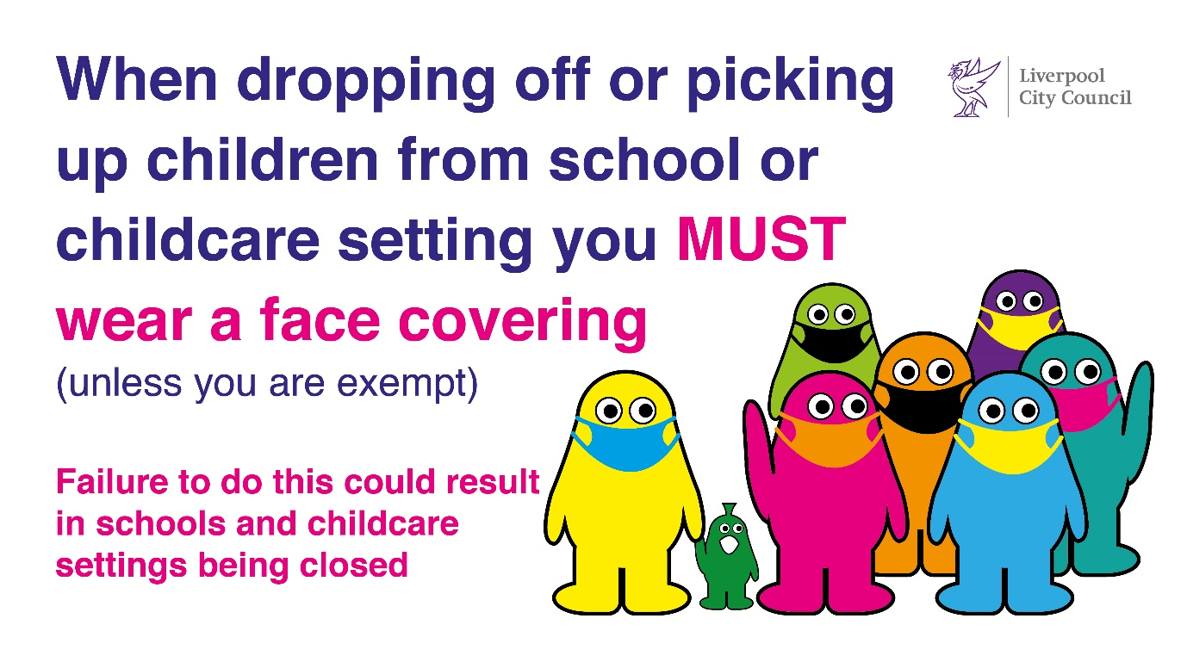
Our ref: JPC/MK
Be Covid Safe
Wear a face covering
Your ref:

26 November 2021

Support Services for

Children and young people in Liverpool

Available to access now

You may find it useful to keep this information

Dear Parents & Carers

Following the tragic incident last night in the city centre, please see below support services that are available to children and young people in Liverpool.

OUT OF HOURS AND EMERGENCY CARE
Below are some options available to children and young people in Liverpool:
You May Just Want Someone To Talk To ...
Below are some phone numbers and links that may be useful:
ALDER HEY CAMHS - CRISIS CARE TEAM
Alder Hey Crisis Care Team – 24 hours a day, seven days a week. The Crisis Care Team offer advice, consultation, and direct intervention to children/young people. and their Families. Contact the team 24/7 on 0151 293 3577.
YOUNGMINDS CRISIS MESSENGER
If you are a young person experiencing a mental health crisis, you can text the YoungMinds Crisis Messenger for free, 24/7 support. Text YM to 85258
For more information visit YoungMinds website here
NHS 111
Where trained health professionals can give you health advice and information 24 hours a day.
Telephone: 111
Click here to go directly to the NHS 111 website
THE SAMARITANS
Offer a 24-hour confidential helpline. Samaritans volunteers listen in confidence to anyone in any type of emotional distress, without judging or telling people what to do.
Telephone: 08457 90 90 90
Textphone: 08457 90 91 92
Click here to go directly to the Samaritans website
CHILDLINE
Childline is here to help anyone under 19 in the UK with any issue they’re going through. Whether it’s something big or small, our trained counsellors are here to support you.
Childline is free, confidential and available anytime, day or night. You can talk to us on the phone, by email or through 1-2-1 counsellor chat. Whatever feels best for you.
Telephone: 0800 1111
1-2-1 Counsellor Chat
BSL Users
Click here to go directly to the Childline website

You May Need To See Someone ...

At times children and young people may become distressed and need to be seen in an emergency. The following is available for children and young people in Liverpool:
GP OUT OF HOURS SERVICE
A GP is available when your local surgery is closed during evenings, weekends and Bank Holidays. If you need urgent healthcare which cannot wait until the next working day, you can access a GP via the GP Out of Hours service. Call your Doctor’s surgery on the usual number and you will either be transferred to the Out of Hours service, or there will be an answer phone message with details of how to access it. The out of hours service operator will take details of your call and pass these to a doctor or nurse, who will contact you and, depending on your circumstances, will offer you one of the following options:
· Telephone advice
· An appointment at a healthcare service in your area that evening
· A home visit

ACCIDENT & EMERGENCY: CHILDREN & YOUNG PEOPLE AGED 0-16 YEARS
If a child or young person becomes distressed or shows signs of becoming a risk to others or themselves they should be taken to A&E at Alder Hey Children’s Foundation Trust following receipt of parental/carer permission. The Specialist mental health service provided by this trust operates a duty on-call system and a clinician will be called to attend A&E to support and provide an assessment of the child or young person. A Psychiatrist on-call system operates through the evening.
ACCIDENT & EMERGENCY: YOUNG PEOPLE AGED 16+
Young people aged 16+ showing signs of distress or becoming a risk to themselves or others should be taken to A&E at the Royal Liverpool University Hospital Trust or University Hospital Aintree. A member of the mental health crisis team will provide an assessment of the young person. This is a 24-hour service.


