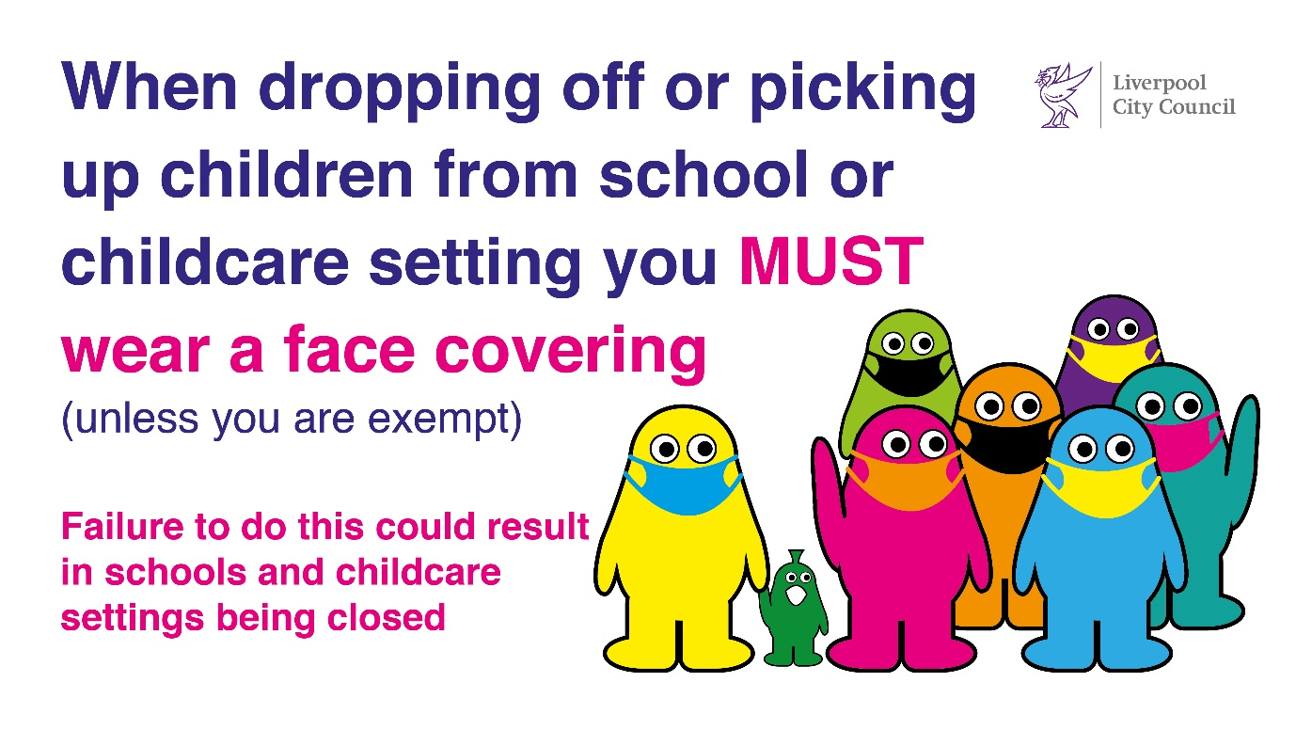
Our ref: JPC/MK
Be Covid Safe
Wear a face covering
Your ref:

16 December 2021

COVID 19 INFORMATION FROM LIVERPOOL CITY COUNCIL:
Matt Ashton, Director of Public Health
Steve Reddy, Director of Children’s Services
You may find it useful to keep this booklet as a reference document.

Key actions people can take to keep themselves and their communities safe

- Get vaccinated
- Get your booster when it’s your turn https://www.nhs.uk/conditions/coronavirus-covid-19/coronavirus-vaccination/coronavirus-booster-vaccine/
- Continue to test regularly – with lateral flow tests
- Wear face coverings in communal areas and when advised / appropriate to do so
- Wear face coverings on public and school transport
- Maximise ventilation
- Maintain good hygiene – wash hands with soap and water or use hand sanitiser
- Self-isolate if not well with Covid-19 symptoms, and get PCR test asap
- Self-isolate if asked by NHS Test and Trace

Mental Health and Wellbeing

Parents and carers - don’t forget about your own self-care. Discover our supportive online mental wellbeing space for adults: qwell.io
The CAMHS Crisis Care Team provides support, advice and guidance to children, families and carers in crisis Telephone: 0151 293 3577 or freephone 0808 196 3550
Talk Liverpool have an urgent 24/7 mental health access line available during the current pandemic Telephone 0151 296 7200 or the freephone number 0800 145 6570
The Samaritans provide a listening service available to all Liverpool parents: Tel: 116 123 free phone line available 24/7
Further local and national information about health and wellbeing: www.liveyourlifewell.info

Please read further information inside.

If you are a contact of a confirmed case, it is also strongly recommended you minimise your contact with anybody who may be classed as vulnerable, to minimise the risk of further spread of covid19.
Individuals who are not double vaccinated are still required to self-isolate as per government guidance here.
We thank you again for your continued support and wish you all an enjoyable and safe Christmas.

Matt Ashton Steve Reddy
Director of Public Health Director of Children’s Services


