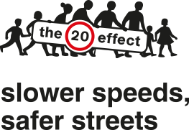

Dear Parents/Guardians,

It will soon be the start of the Christmas Holidays and a time for your children to be relaxing and having fun. Please remind them about keeping safe near the roads, checking all around with no distractions before crossing, especially when out and about with their friends. It is important to be visible to the drivers and more so when dark, also in icy and wet conditions.

They may receive new gifts such as bikes, skateboards, scooters so maybe look at including a helmet to give them added protection when on the roads. Lights front & back plus reflectors are a legal requirement on bikes if cycling as it gets dark.

E-scooters if brought are only to be ridden on private land at the owner’s permission, this is usually in small print when purchasing. They are not legal to be used on the Highway, the only legal e-scooters are the pilot Voi hire, you must have to be 18 or over with a driving licence to use them.

Remember when in the car all passengers are to wear seatbelts (unless exempt) for all journeys, have your children in the legal correct child car seat if required for their age and height. As a driver it is important to drive at the correct speeds with residential areas being 20mph.

Remember if you are a driver and have been drinking the night before you may not be safe to drive the following morning. Many motorists pulled over by the police and breathalysed are still over the limit the next day whilst driving. Alcohol stays in your system for a long period of time……………...
https://morning-after.org.uk

.

Think about the safety of all Road Users

Have a safe & happy Christmas

Road Safety Team
Liverpool City Council

