

Class | Merit Award | Friendship Award | Special Award
1 | Tasneem Ali | Elijah Lyons-Hughes | David Conroy
2 | Elsa Adloo | Aniel Heidarian | Alby Hartley
3 | Stephen Jensen Waters | Karol Galon | Lucie Fitzsimmons
4 | Amy McNulty | Rhia Wilcott | Nabila Mohamoud
5 | Eva Davies | Mohamed Mahmoud | Cali Clarke
6 | Kenean Andeberhan | Khalil Bedja | Miracle Kokey










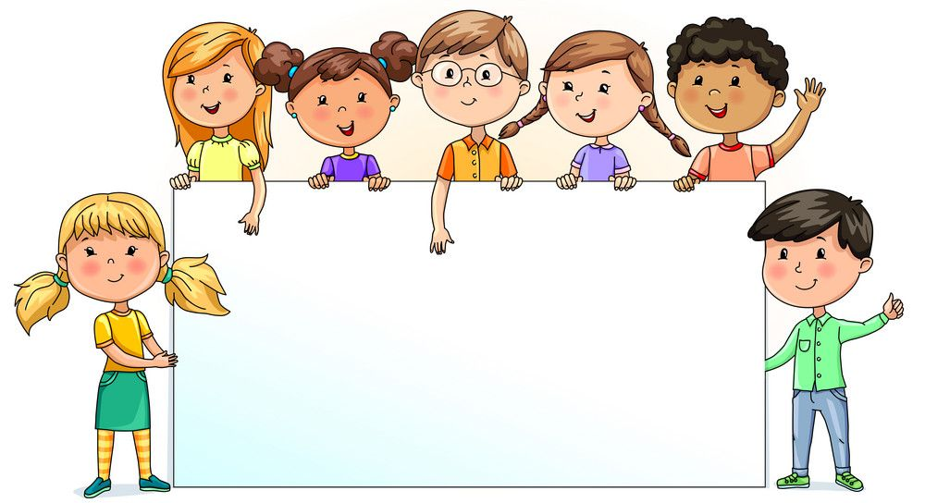

Nursery  % | Reception  % | Year 1  % | Year 2  % | Year 3  % | Year 4  % | Year 5  % | Year 6  %
52.81 | 80.41 | 88.94 | 95.29 | 88.10 | 91.43 | 93.79 | 91.76

