

Class | Merit Award | Friendship Award | Special Award
1 | Ibrahim Kaya | Jaylen Tendo | Grace Decourcy
2 | Siana Jolla | Keniel Araya | Andrea Bweya
3 | Yodit Gebremeskel Berhane | Adelina-Maria Parus | Karol Galon
4 | Tatiana Burjanska | Amelia Hughes | Jacob Wincz
5 | Kaiden Deakin | Amelia Miller | Isaiah Tendo
6 | Nawal Mohamoud | Dylan Gilbertson | Evie Miller










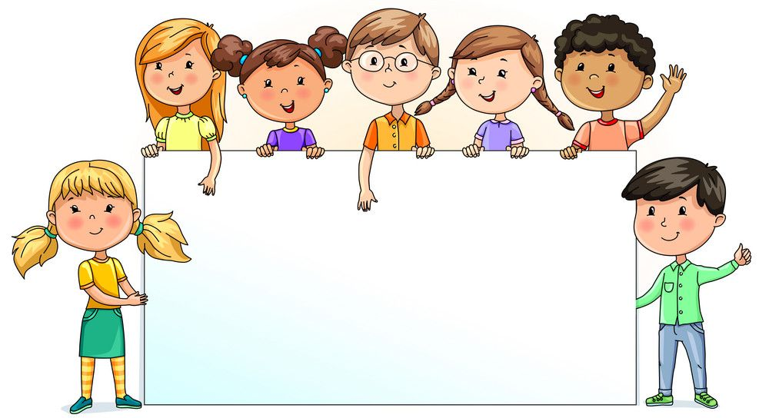

Nursery  % | Reception  % | Year 1  % | Year 2  % | Year 3  % | Year 4  % | Year 5  % | Year 6  %
58.51 | 82.50 | 98.10 | 98.75 | 97.14 | 92.03 | 91.43 | 93.98

