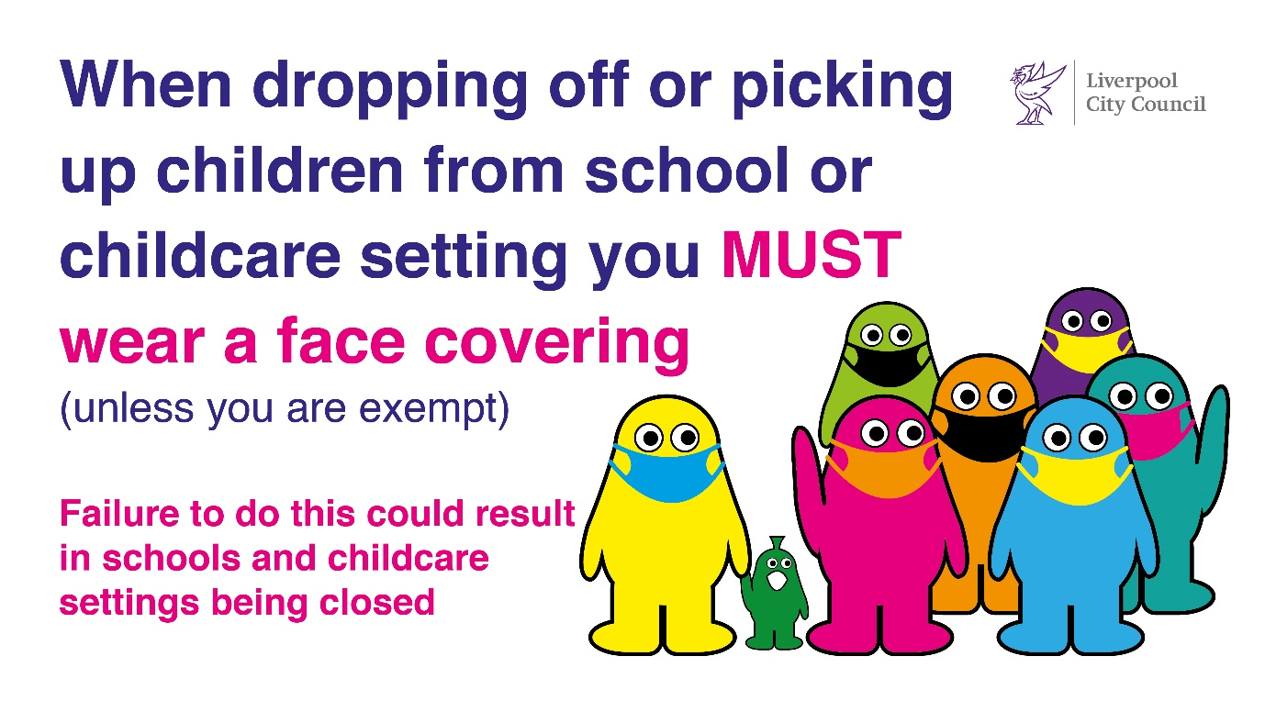
Our ref: JPC/MK
Be Covid Safe
Wear a face covering
Your ref:

January 2022

FAO: Year 6 Parents

Dear Parents and Carers

CAMPUS VISIT

We have arranged an interesting and enjoyable day out at Liverpool University for Year 6.

The day is designed for children to get to know all about going to University and an opportunity to look around the campus and visit the Victoria Gallery and Museum.

DETAILS:
- Tuesday 1st February
- Leave school at 9.15
- School uniform is required
- We will return to school for the end of the day.
- Children will need a packed lunch in a throwaway bag please with a non-fizzy drink
- Transport is also provided – no charge

Please complete and return the reply slip attached.

Yours sincerely
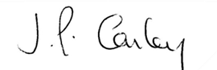

Mrs J P Conley
Headteacher


