

Class | Merit Award | Friendship Award | Special Award
1 | Milion Gebremeskel Berhane | Lucas Brophy | Rosie O’Callaghan
2 | Adam Jaouadi | Adam Suleman | Andrea Bweya
3 | Alfie Clegg | Yodit Gebremeskel Berhane | Yadiail Araya
4 | Nabila Mohamoud | Amy McNulty | Jacob Wincz
5 | Frezghi Tsegay | Nasra Ibrahim | Cristian Vasilescu
6 | Madison Cave | Tina He | Miracle Kokey

+










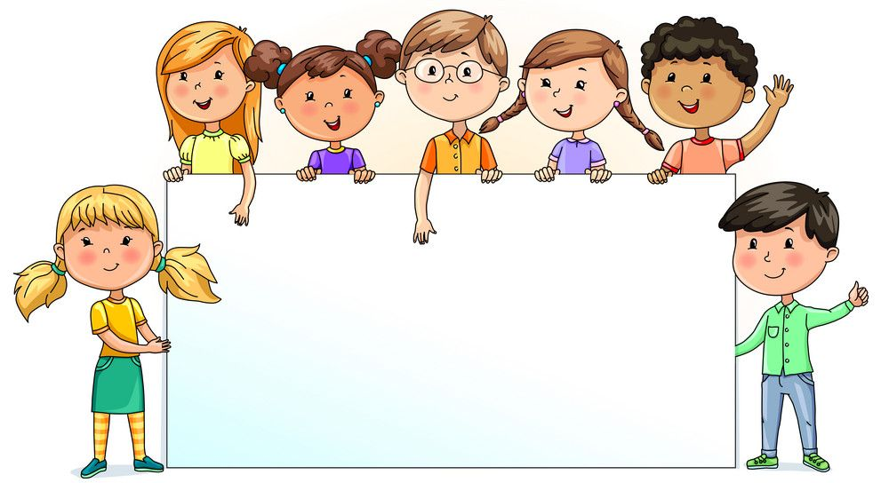

Nursery  % | Reception  % | Year 1  % | Year 2  % | Year 3  % | Year 4  % | Year 5  % | Year 6  %
78.26 | 89.55 | 80.00 | 94.74 | 96.46 | 92.86 | 91.67 | 88.82

