

Class | Merit Award | Friendship Award | Special Award
1 | George Disley | David Conroy | Rosalie Clements
2 | Luke Moore | Elena Al-Hakami | Elsa Adloo
3 | Eskyas Tsegay | Adelina-Maria Parus | Adam Conroy
4 | Lottie Creegan | Daniel Deakin | Scarlett Gallagher
5 | Ethan McPartlin | Jacob Gilbertson | Kristian Morris
6 | Maisie Johnson | Nawal Mohamoud | Madison Cave

+










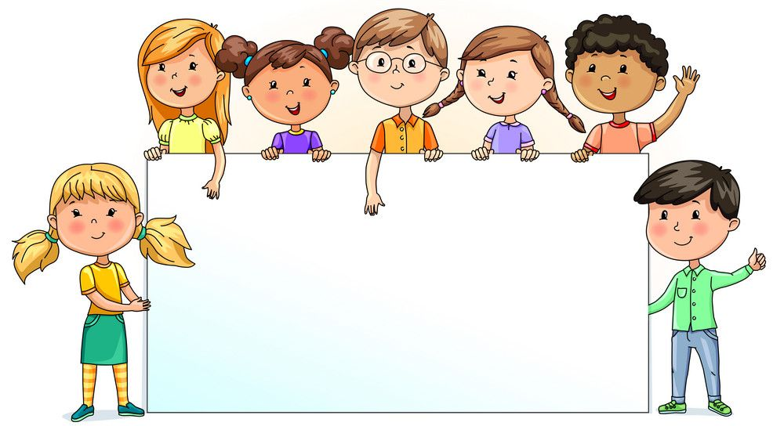

Nursery  % | Reception  % | Year 1  % | Year 2  % | Year 3  % | Year 4  % | Year 5  % | Year 6  %
86.42 | 87.27 | 97.00 | 83.68 | 95.24 | 95.86 | 97.33 | 97.50

