
Our ref: JPC/MK
Your ref:

28 June 2022


Dear Year 1 Parent/Carer

I want to take this opportunity to say how proud I am of the children in Y1.

Last week, they achieved 100% attendance every day! Yours and their commitment to attendance gave our Y1 a week jam-packed with learning and time to spend with their school friends and staff.

Thank you for instilling in our children that education is important.

Please continue to support your child by sending them in to school every day. Attendance matters and it is proven that children with great attendance rates really do achieve their dreams and aspirations.
















Yours sincerely
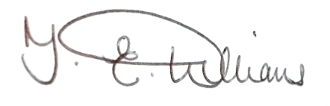

T E Williams
Deputy Head teacher

