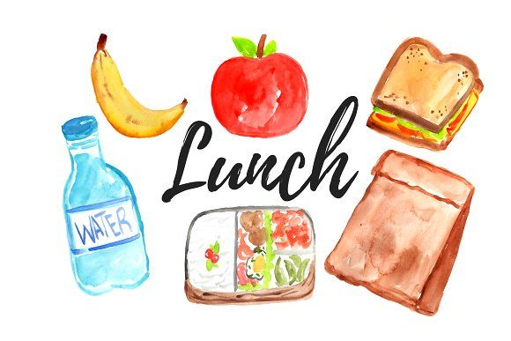

Bless us O God

as we sit together**.**

Blessthe food

we eat today.

Blessthe hands

that made the food.

Bless us O God**.**

Amen